Western Mathematics Exams

Yearly Examination

2015
Year 10
Mathematics Course

Solutions
Year 10 |  | WME Yearly Maths | Non Calculator
Section 1 Short Answer Section
ANSWERS
No. | WORKING |  | ANSWER
 | 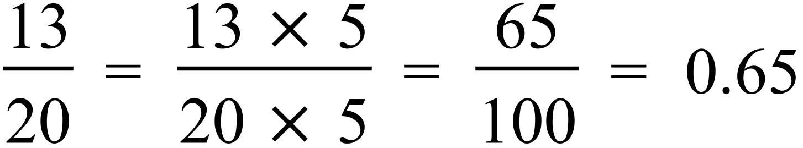  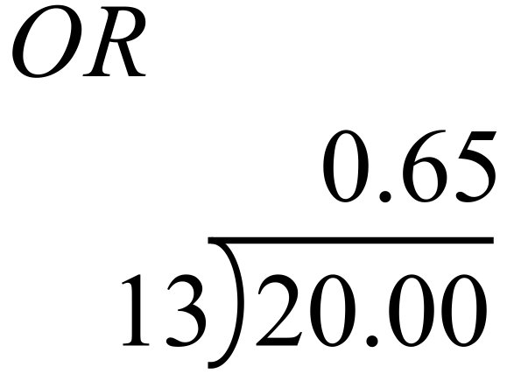 |  | 0.65
 | 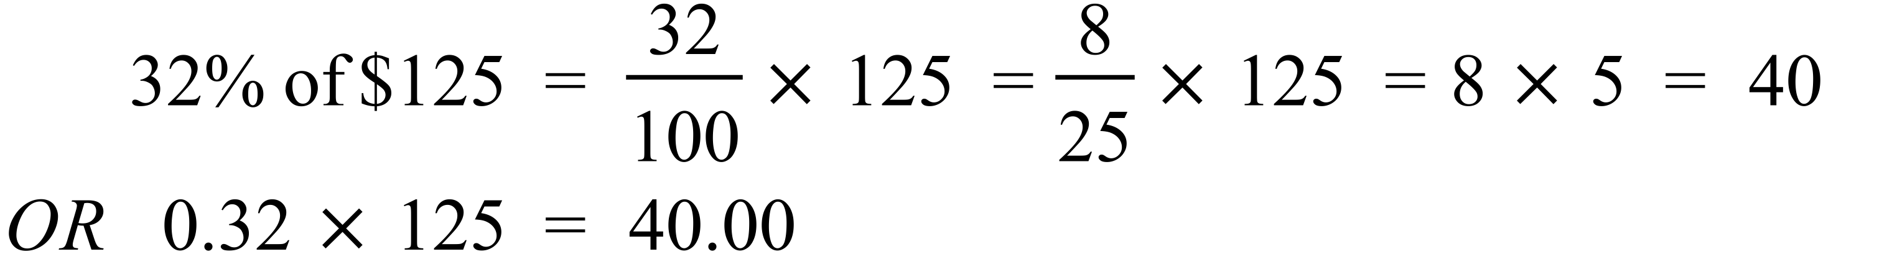 |  | $40
 |  |  | $960
 | 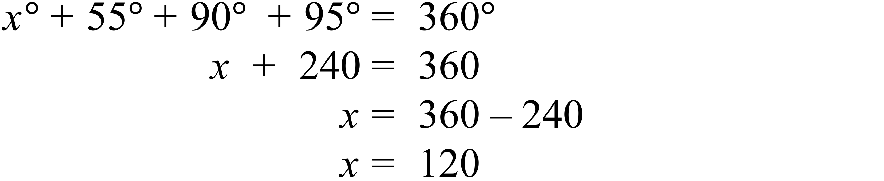 |  | 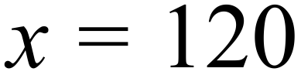
 | 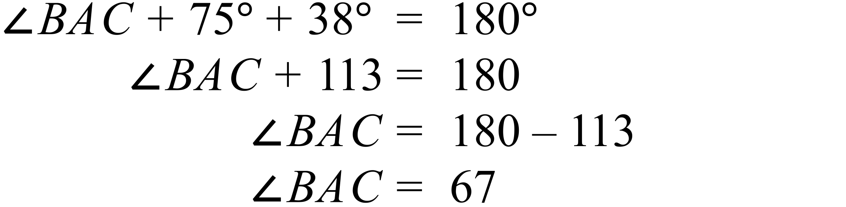 |  | 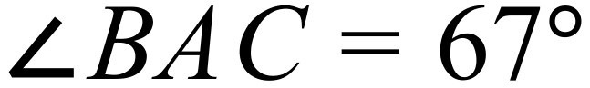
 | 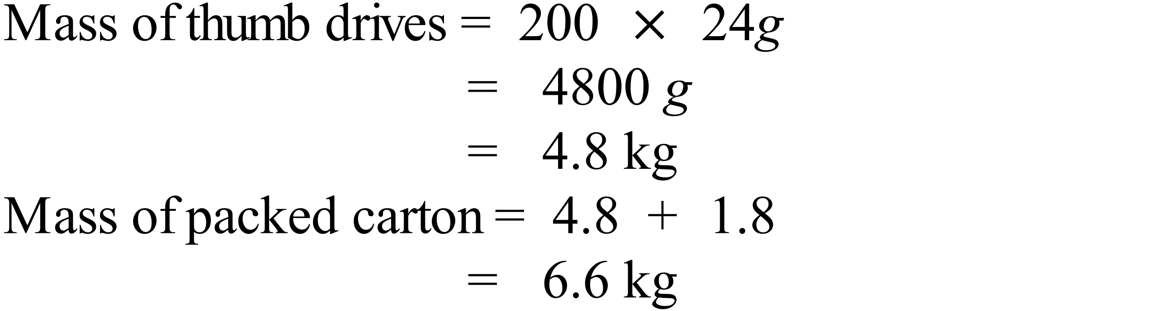 |  | 6.6 kg
 | 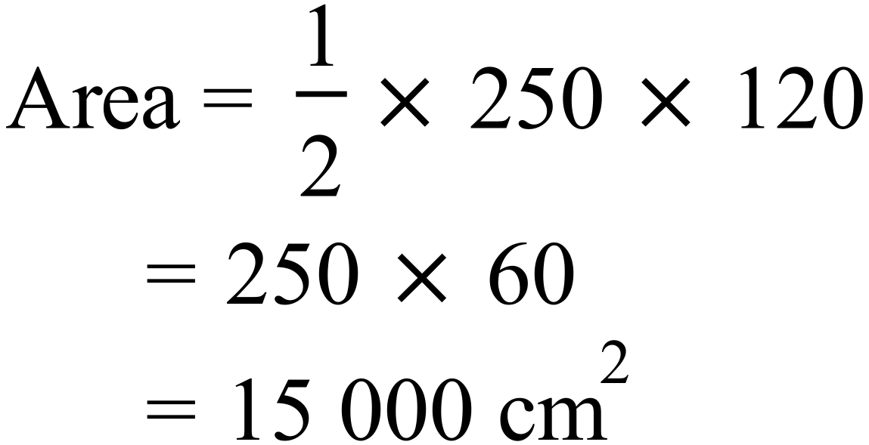 |  | 15 000 cm²
 | 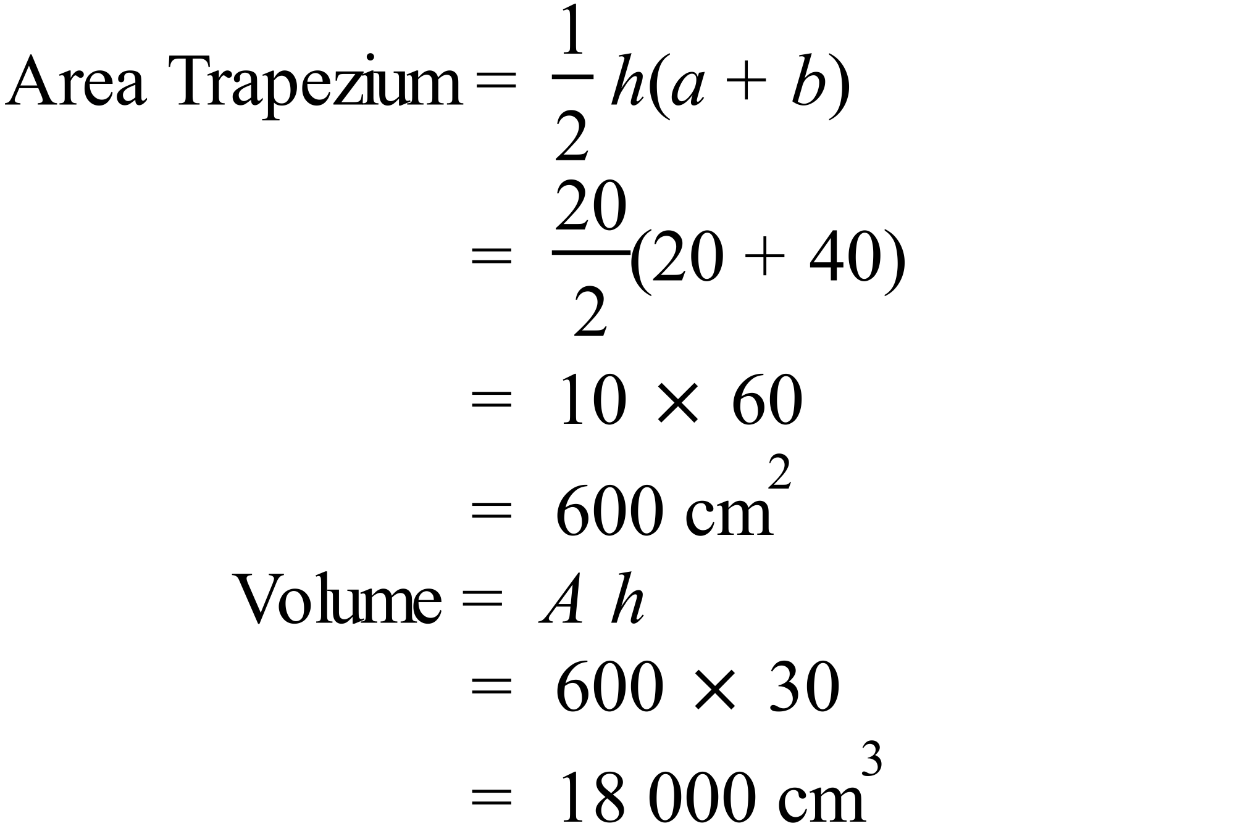 |  | 18 000 cm³
 | 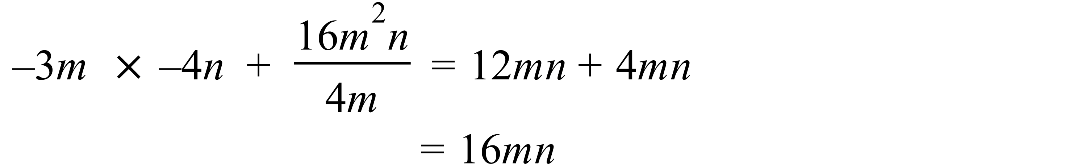 |  | 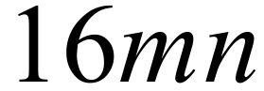
 |  |  | 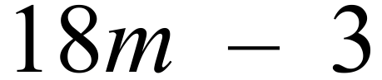
 | 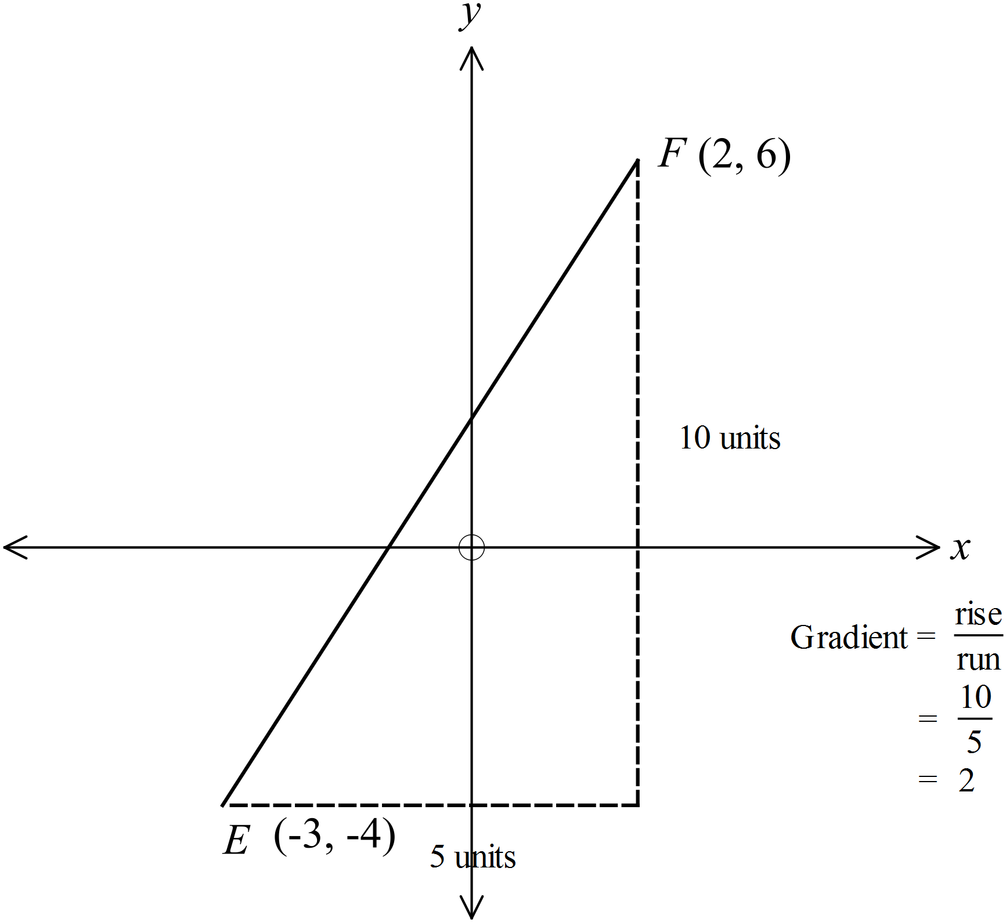 |  | Gradient = 2
 | 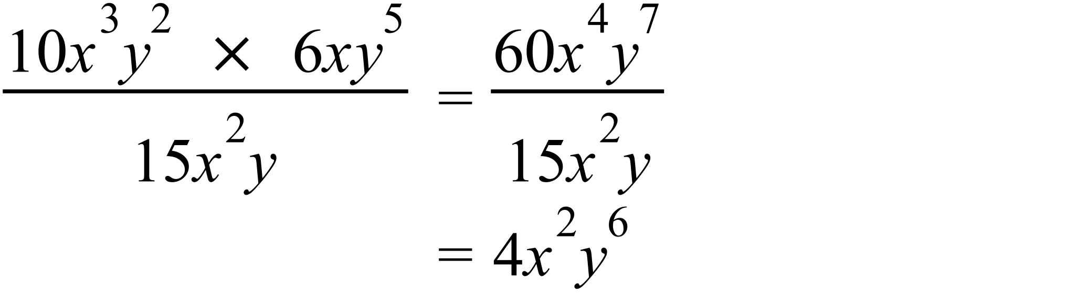 |  | 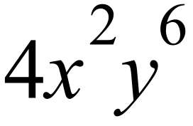
 | 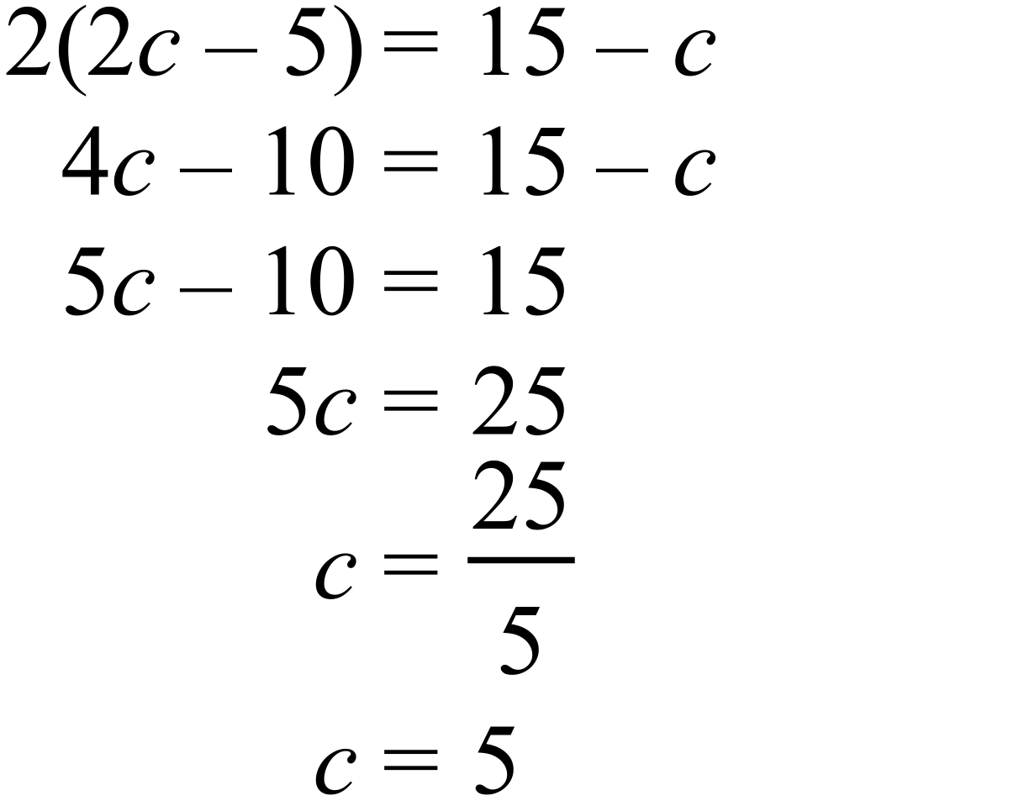 |  | 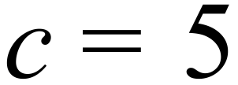
 | 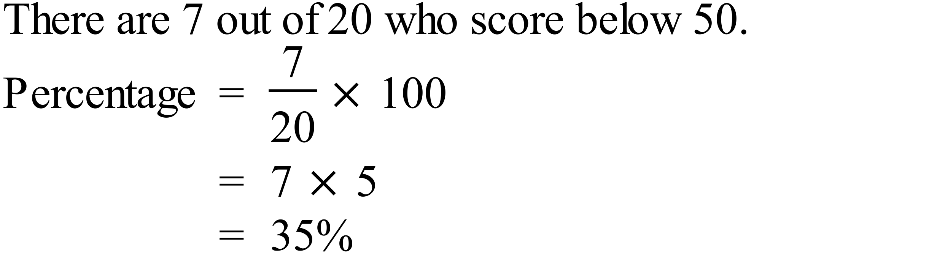 |  | 35%
   |  |  |  |  | ⃝
   |  |  |  |  | ⃝ | ⃝
   |  |  | ⃝ | ⃝ | ⃝ | ⃝
   |  | ⃝ | ⃝ | ⃝ | ⃝ | ⃝
  ⃝ | ⃝ | ⃝ | ⃝ | ⃝ | ⃝ | ⃝ | ⃝
  46 | 47 | 48 | 49 | 50 | 51 | 52 | 53
 | 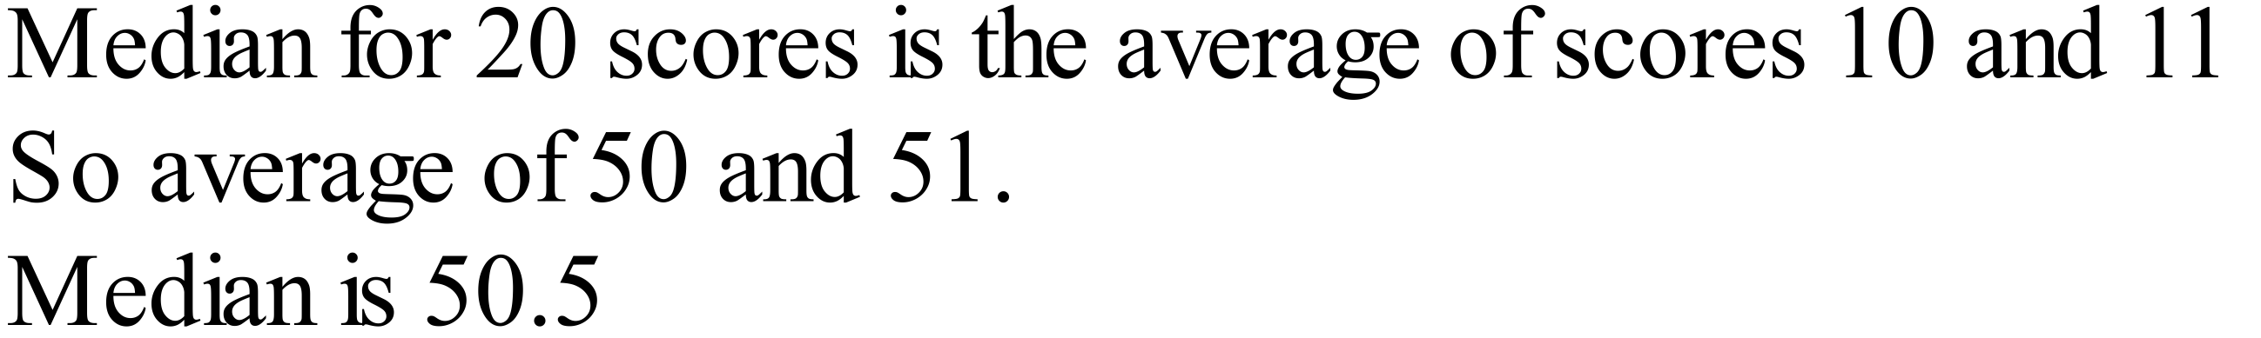 |  | 50.5
 | 12.5 : 50 = 125 : 500  = 5 : 20  = 1 : 4 |  | 1 : 4
 | 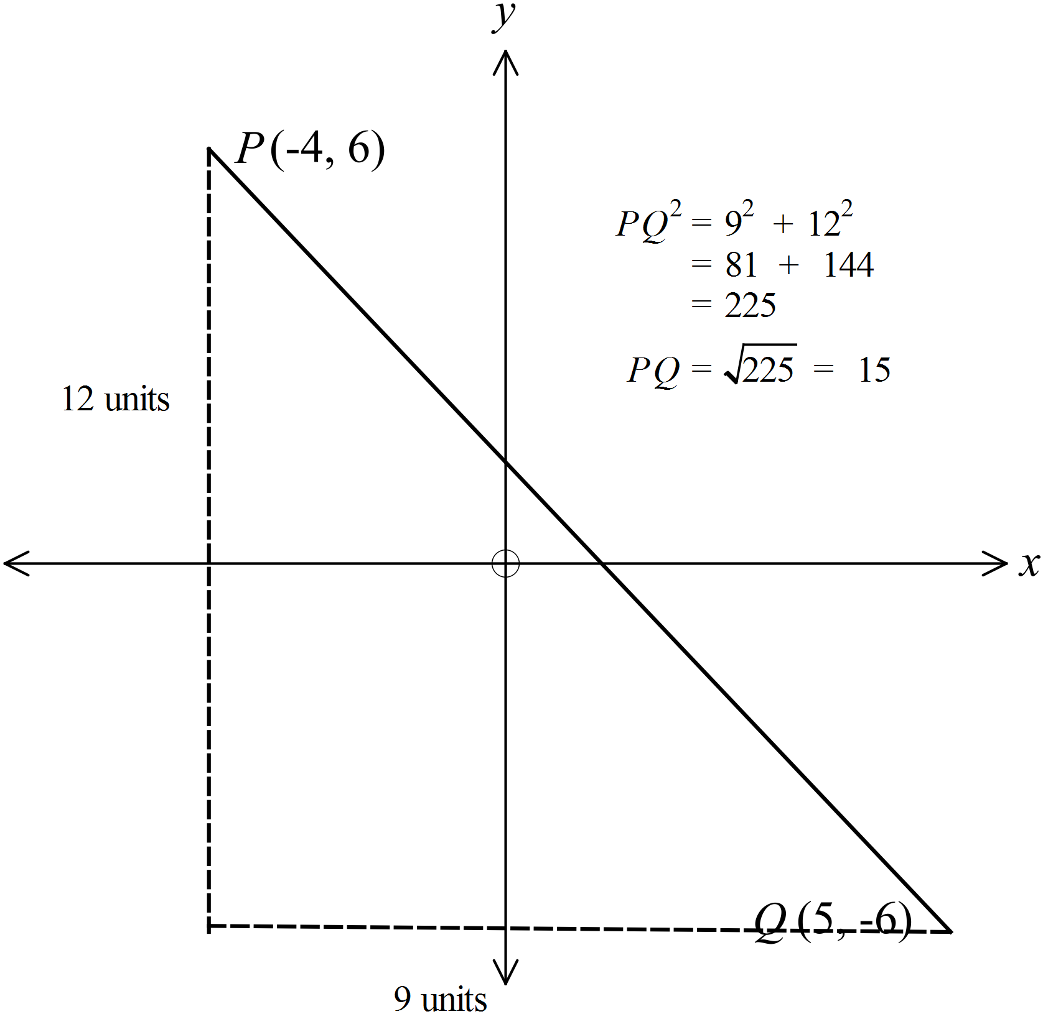 |  | 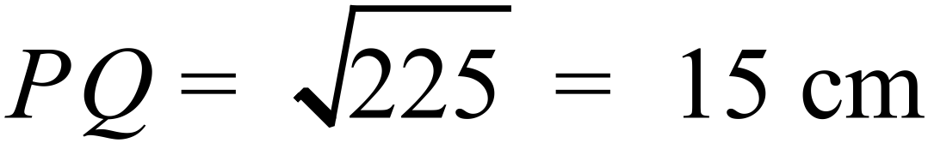
 | 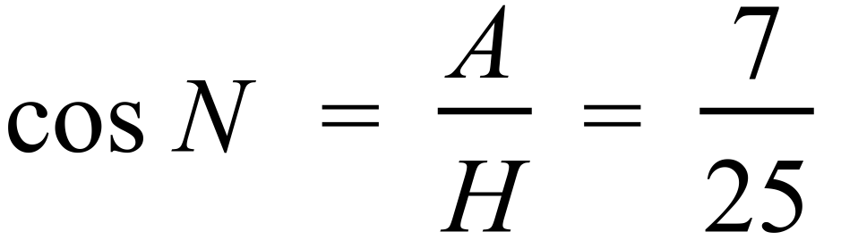 |  | 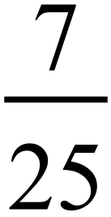
 | 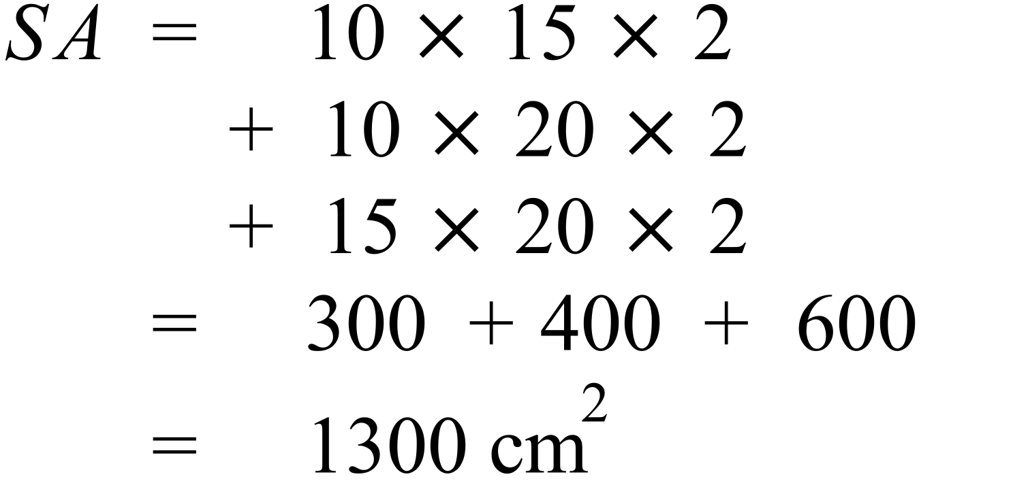 |  | 1300 cm²
 | 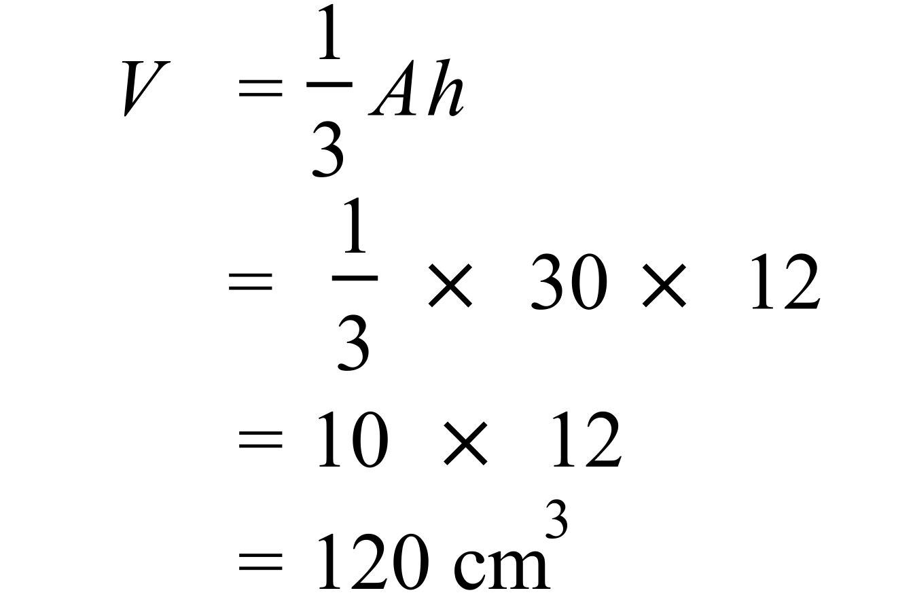 |  | 120 cm³
The points A’ and B’ need to be located by any reasonable construction method and the triangle drawn and labelled.
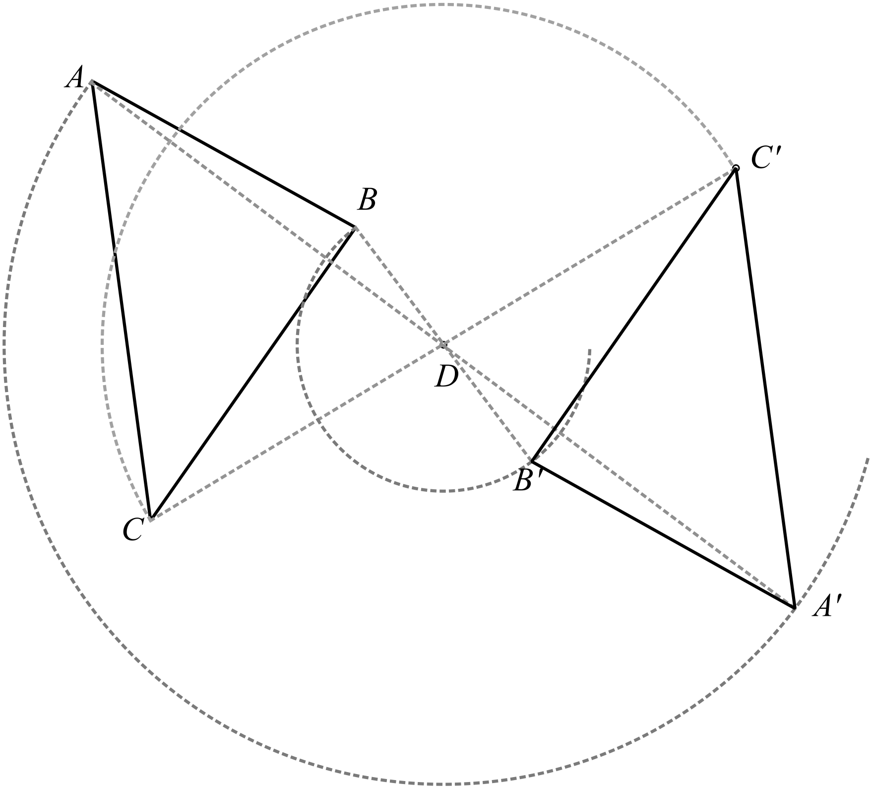

 | There are 5 black counters, 5 patterned counters and 4 white counters, so both black and patterned have a 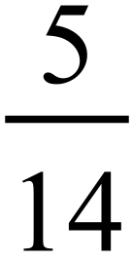 chance of being picked up. |  | Black and Patterned
 | 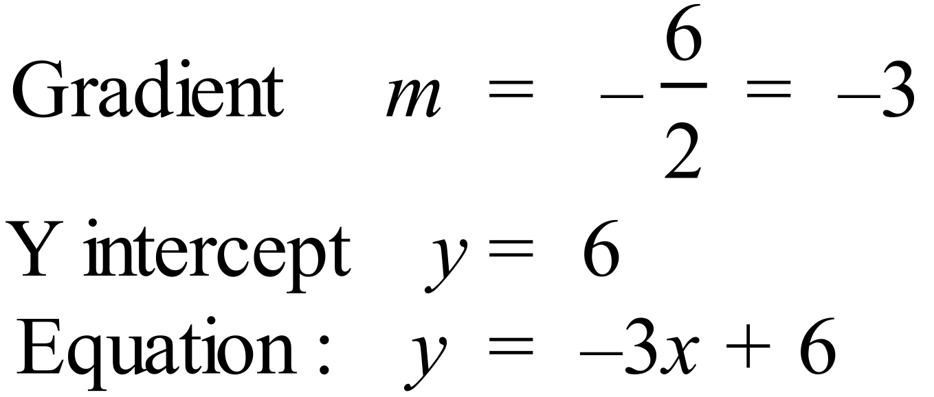 |  | 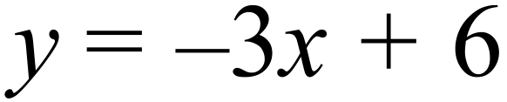
 | 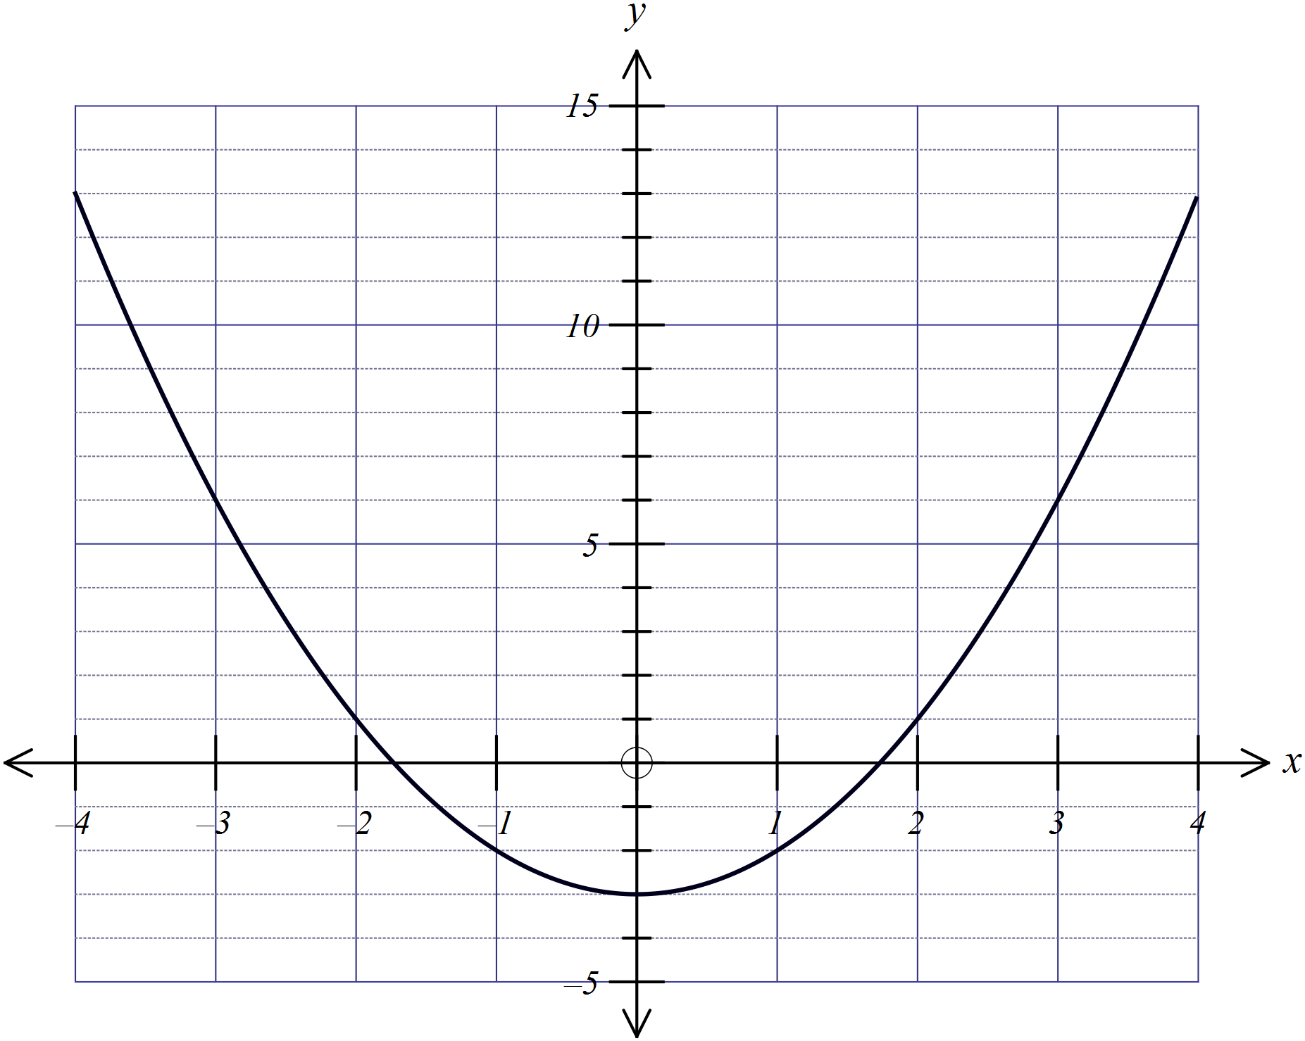
 | 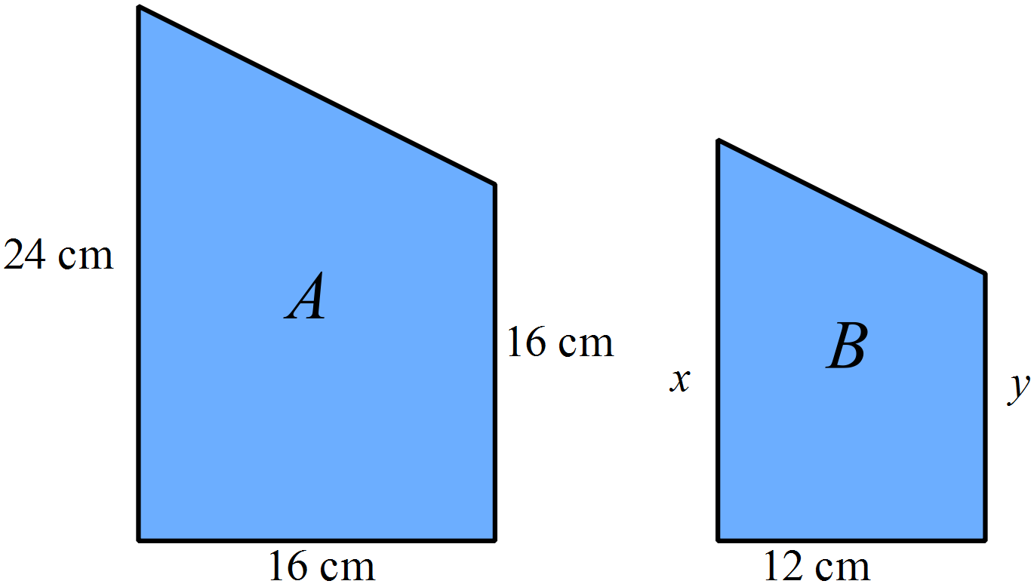  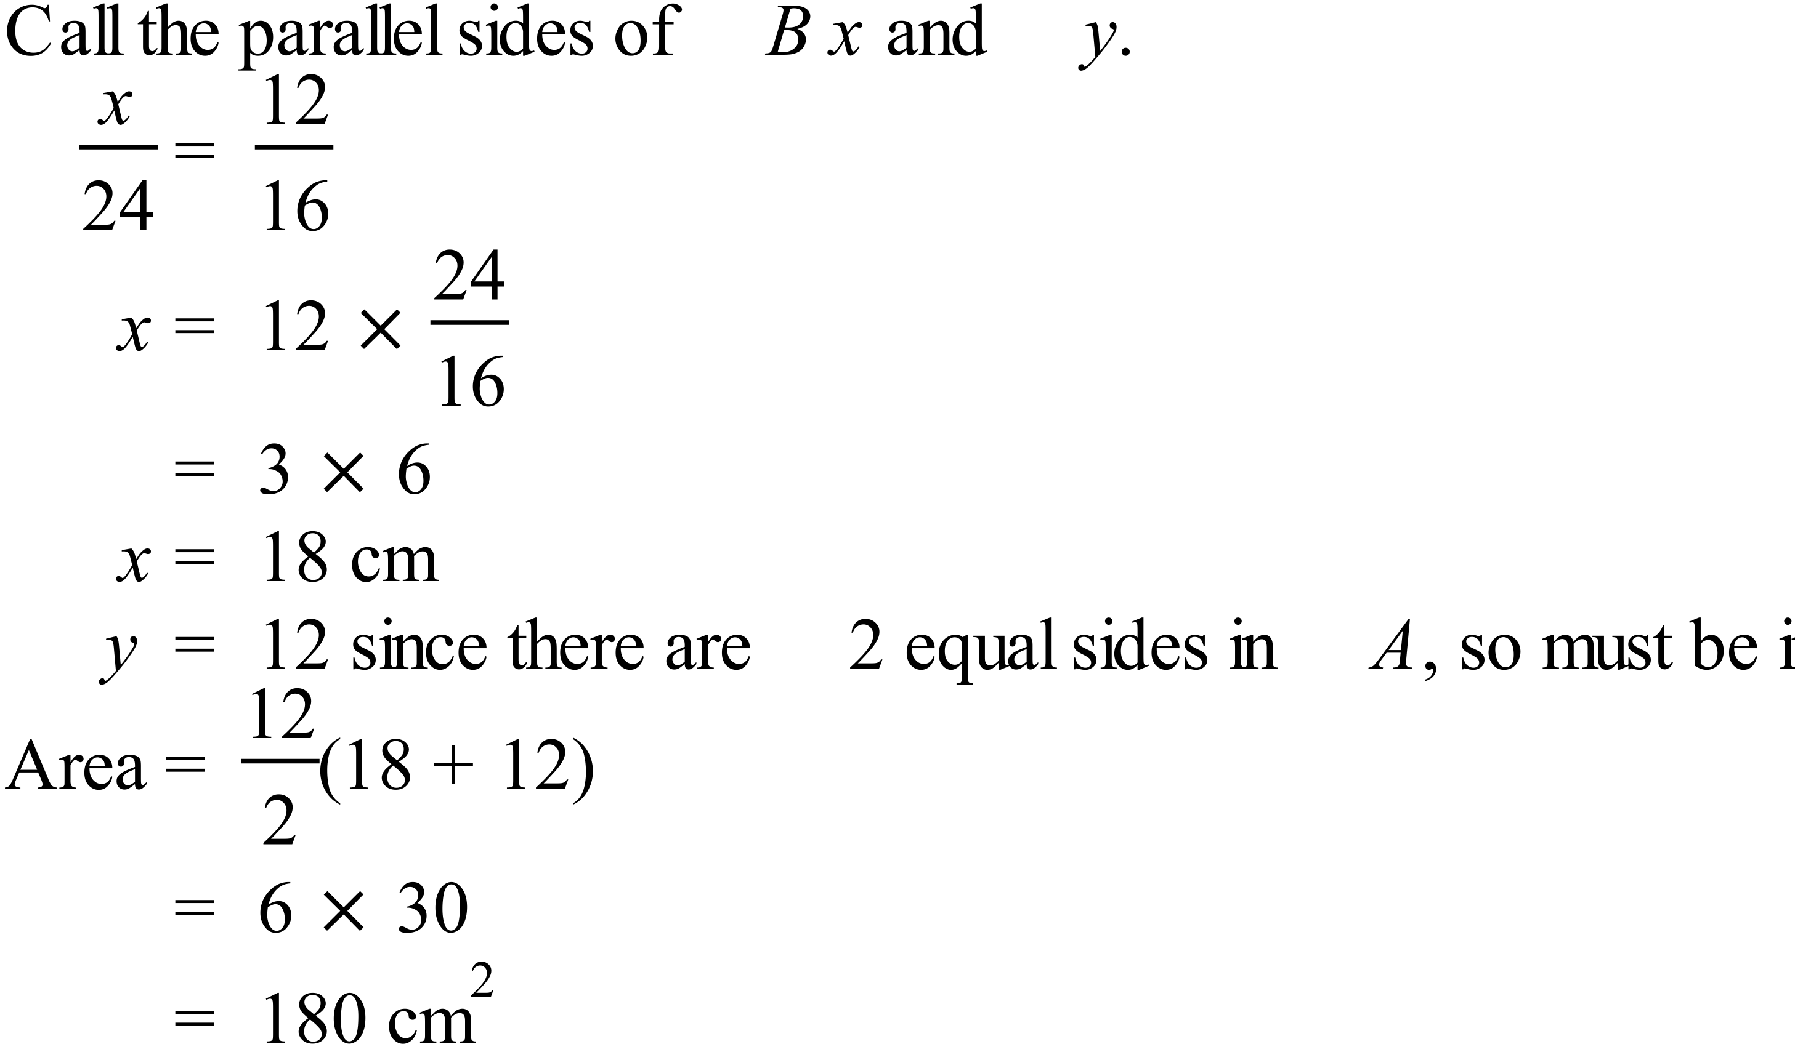  Can also be done by ratio of areas.  Ratios of Length A : Length B = 4:3  So ratio Area A : Area B = 16:9  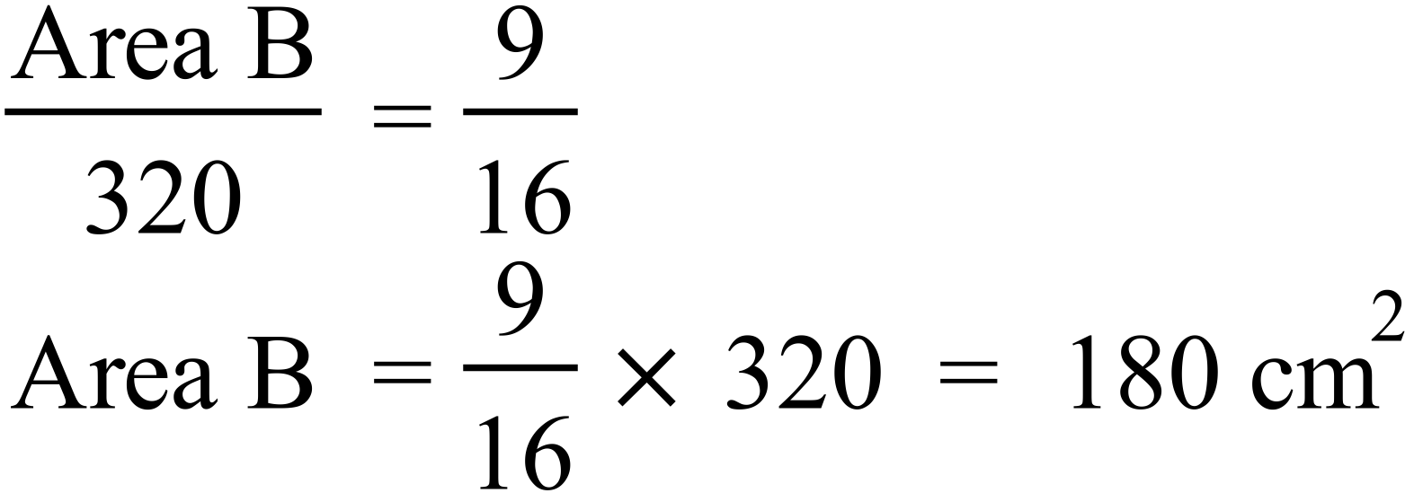 |  | 180 cm²

Year 10 |  | WME Yearly Maths | Calculator Allowed
Section 2 Part A Multiple Choice Section
ANSWERS
No. | WORKING |  |  | ANSWER
 | 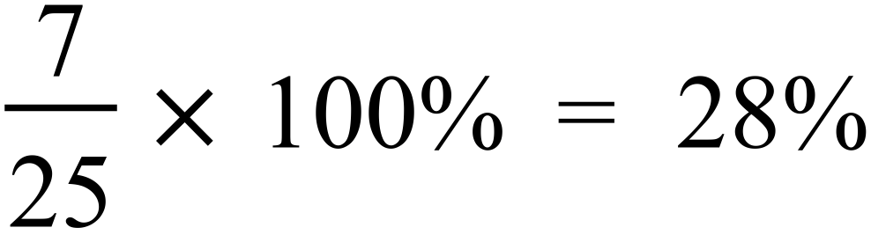 |  |  | C
 |  |  |  | C
 | A. $840 per week =  B. $1650 per fortnight =  C. $3580 per month =  D. $43 500 per annum. |  |  | A
 | 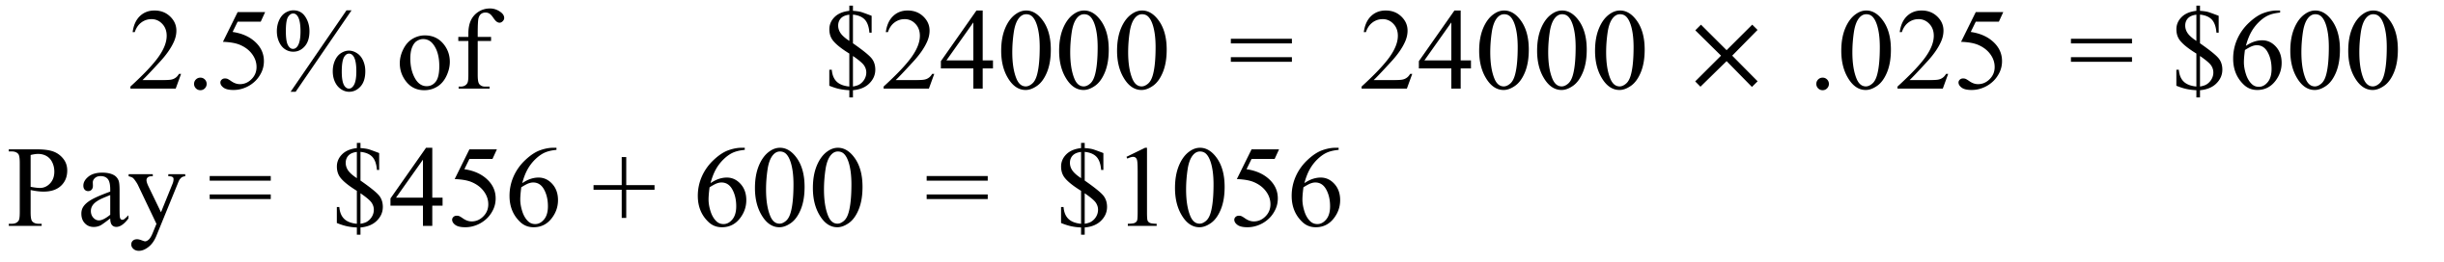 |  |  | B
 | 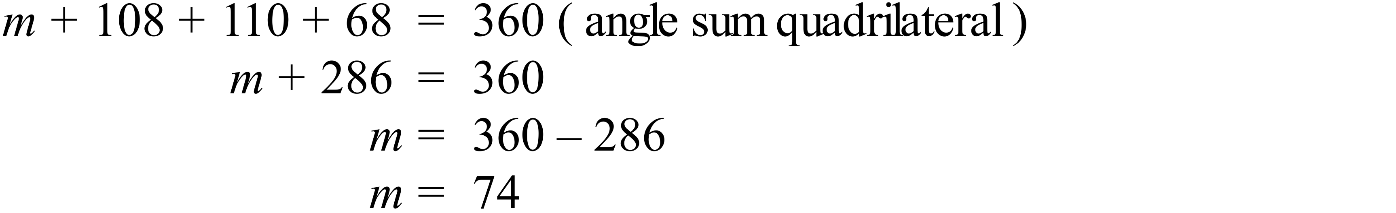 |  |  | A
 | 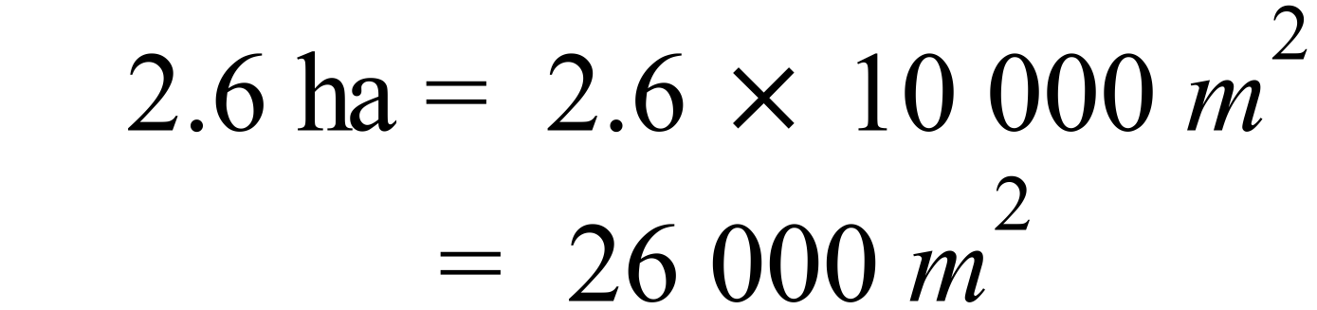 |  |  | D
 | 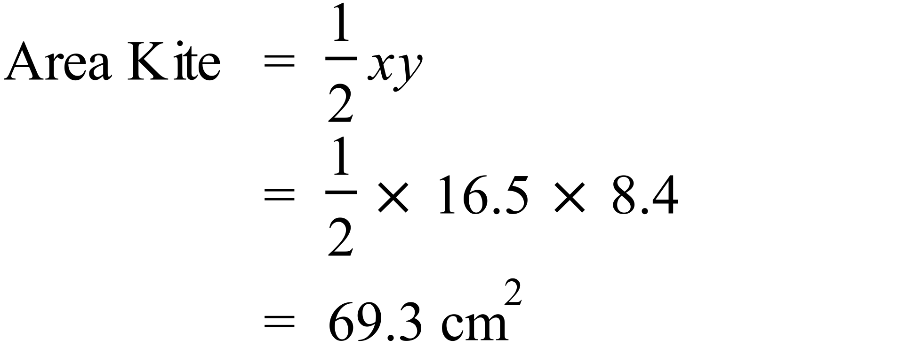 |  |  | C
 |  |  |  | C
 | 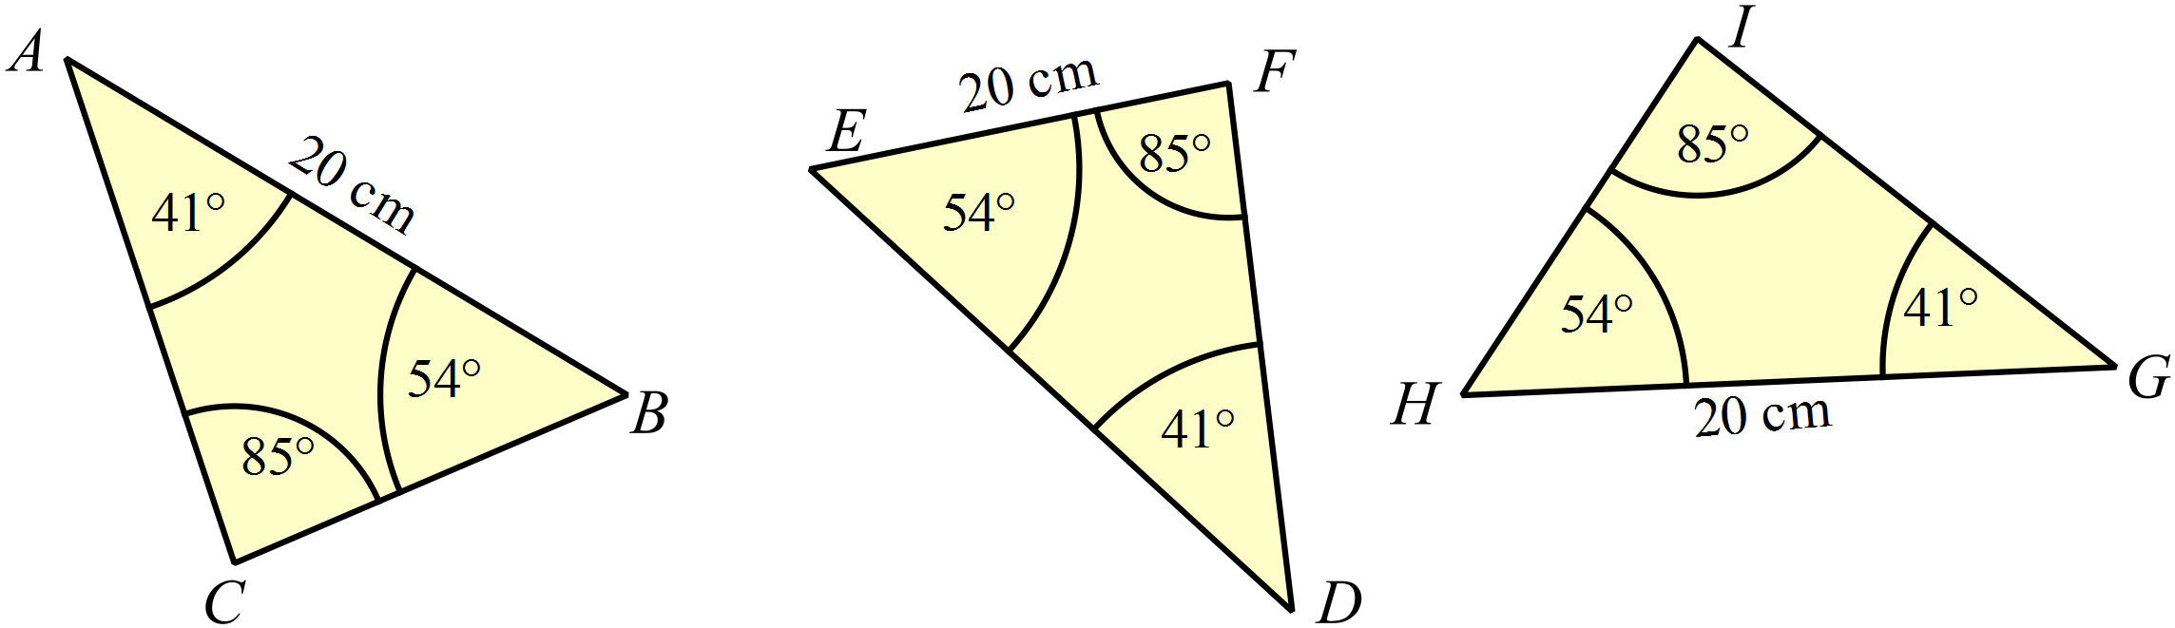  Completing the missing angles, all three triangles are equiangular.  Comparing the known side, only 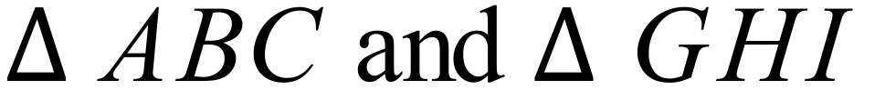 have the side between the same angles, so they are congruent. |  |  | B
 | 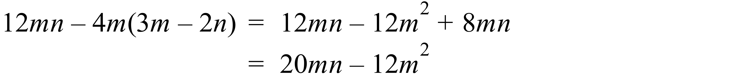 |  |  | D
 | Between 1900 and 1920 there was a drop of 1800, (50% decrease) which is the biggest change, in both absolute and relative terms. |  |  | D
 | A(–4, 6) and B(–10, –8).  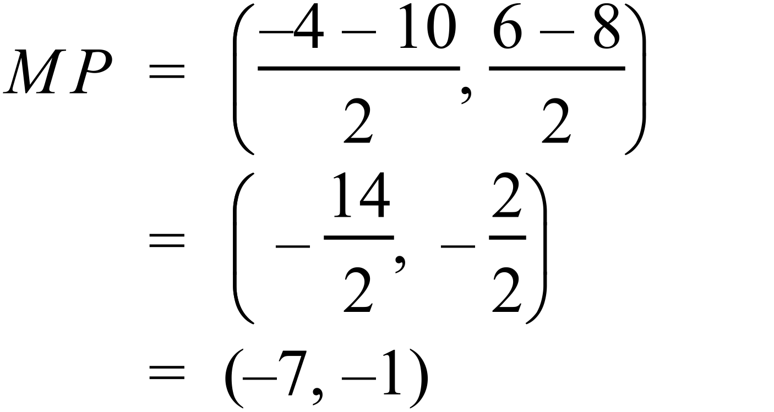 |  |  | B
 | 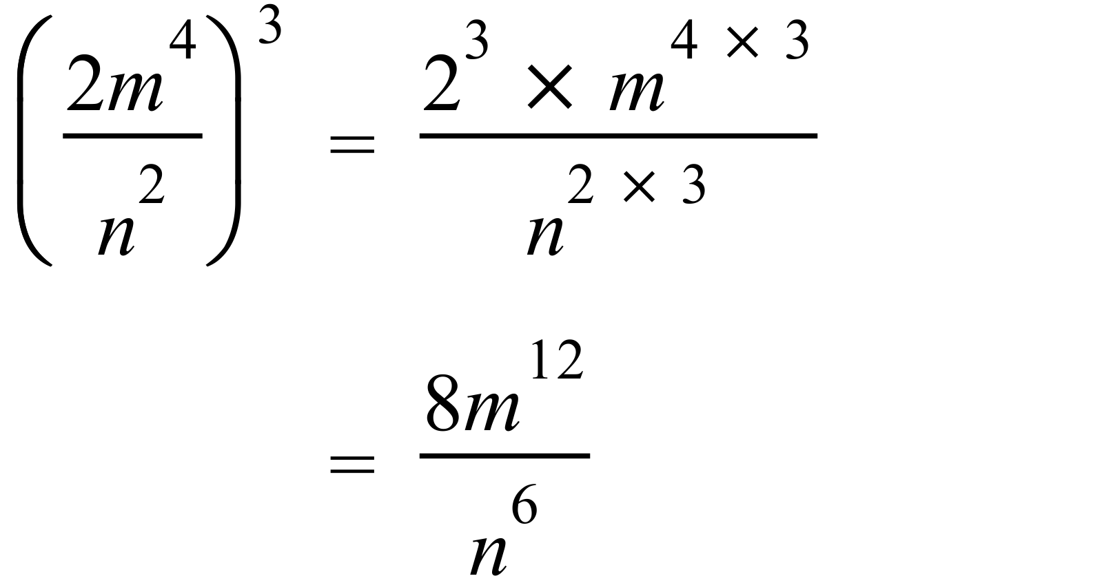 |  |  | D
 | 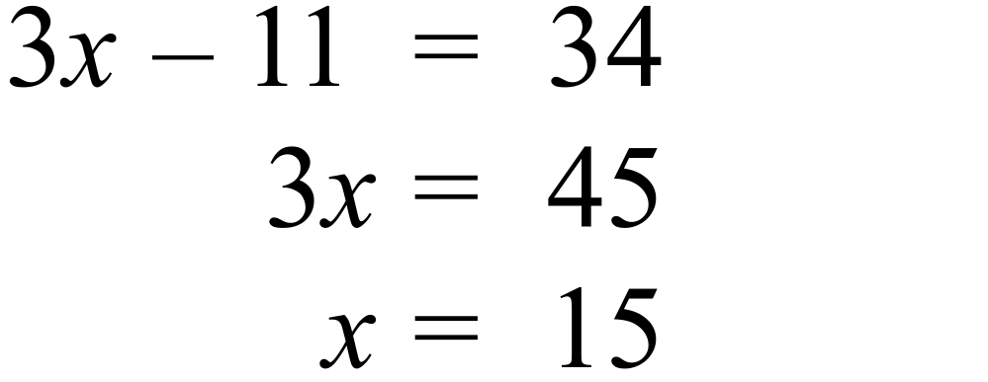 |  |  | A
 | Training time : Playing time = 7 : 5  = 28 : P  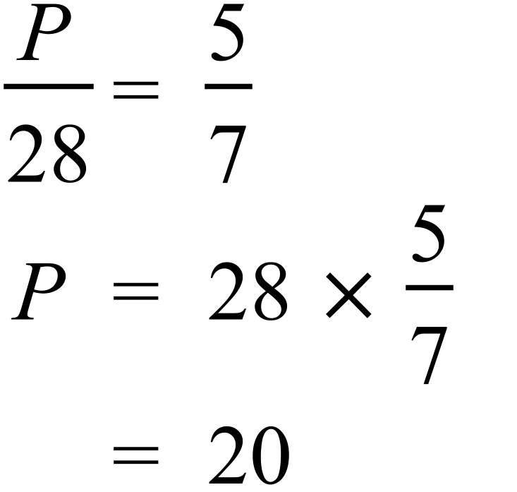 |  |  | A
 | 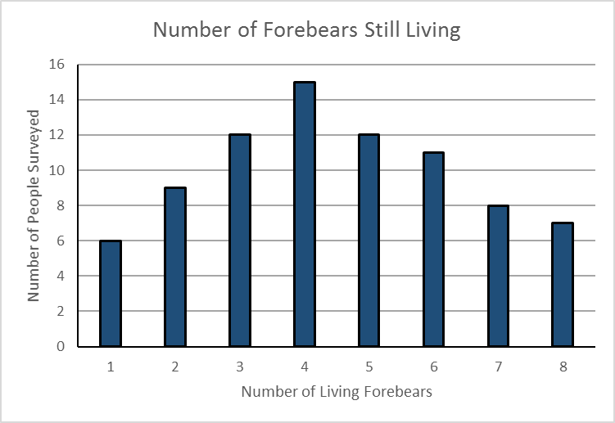  Number with more than four = 12 + 11 + 8 + 7 = 38  Percentage = 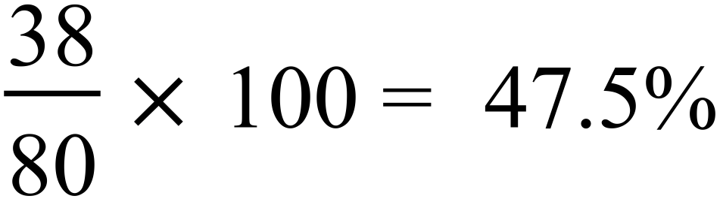 |  |  | B
 | 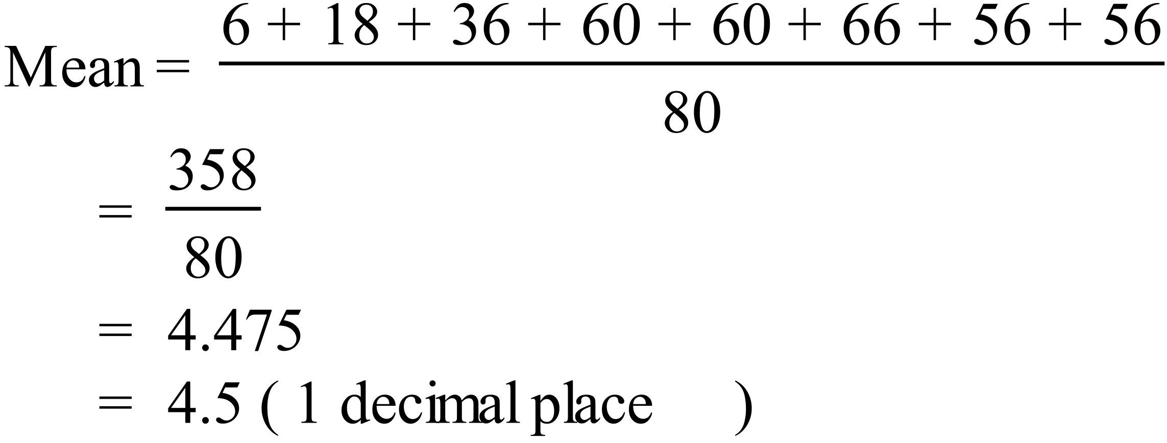 |  |  | D
 | 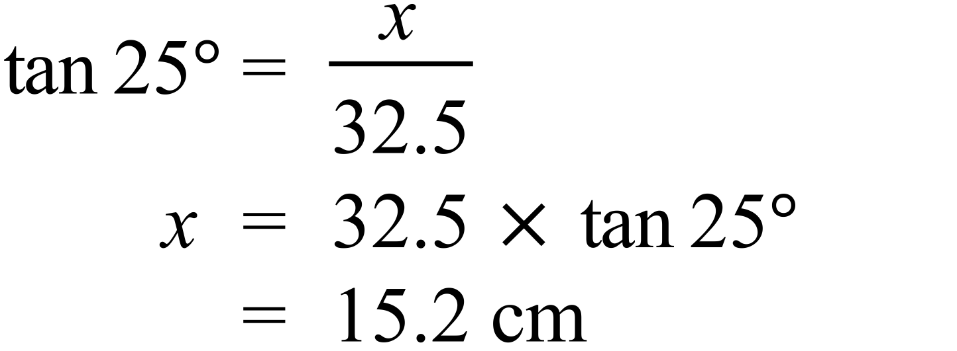 |  |  | B
 | 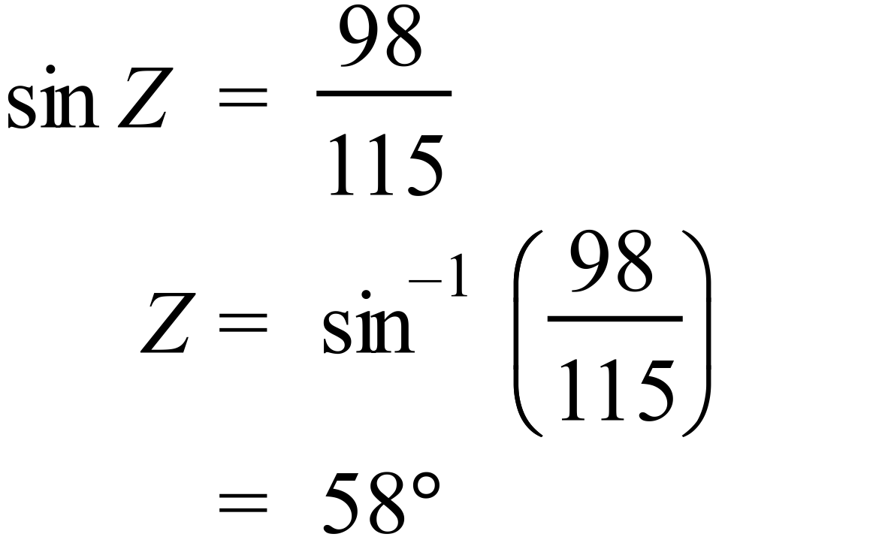 |  |  | D
 | 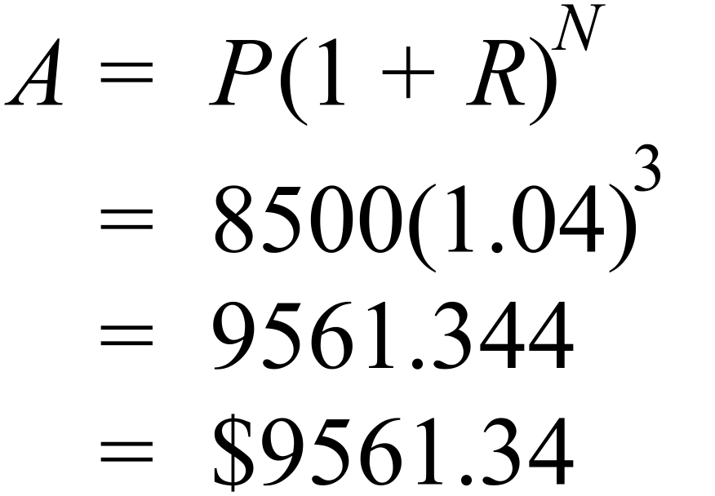 |  |  | C
 | 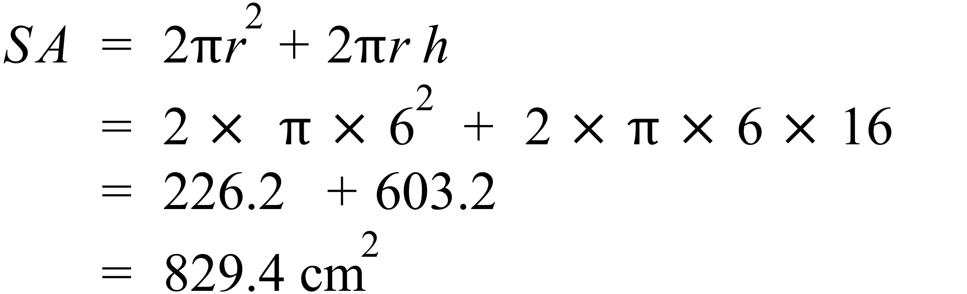 |  |  | D
 | 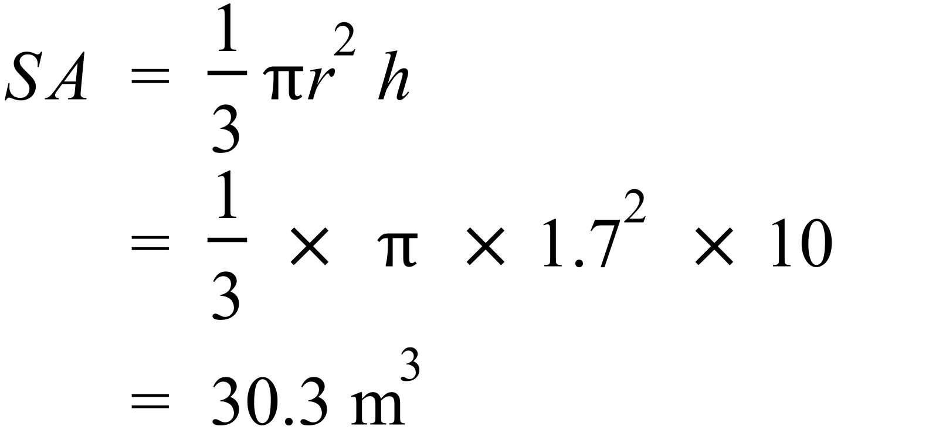 |  |  | A
 | 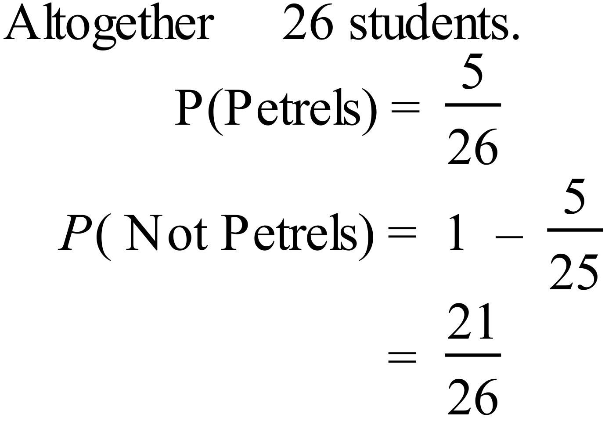 |  |  | C
 | 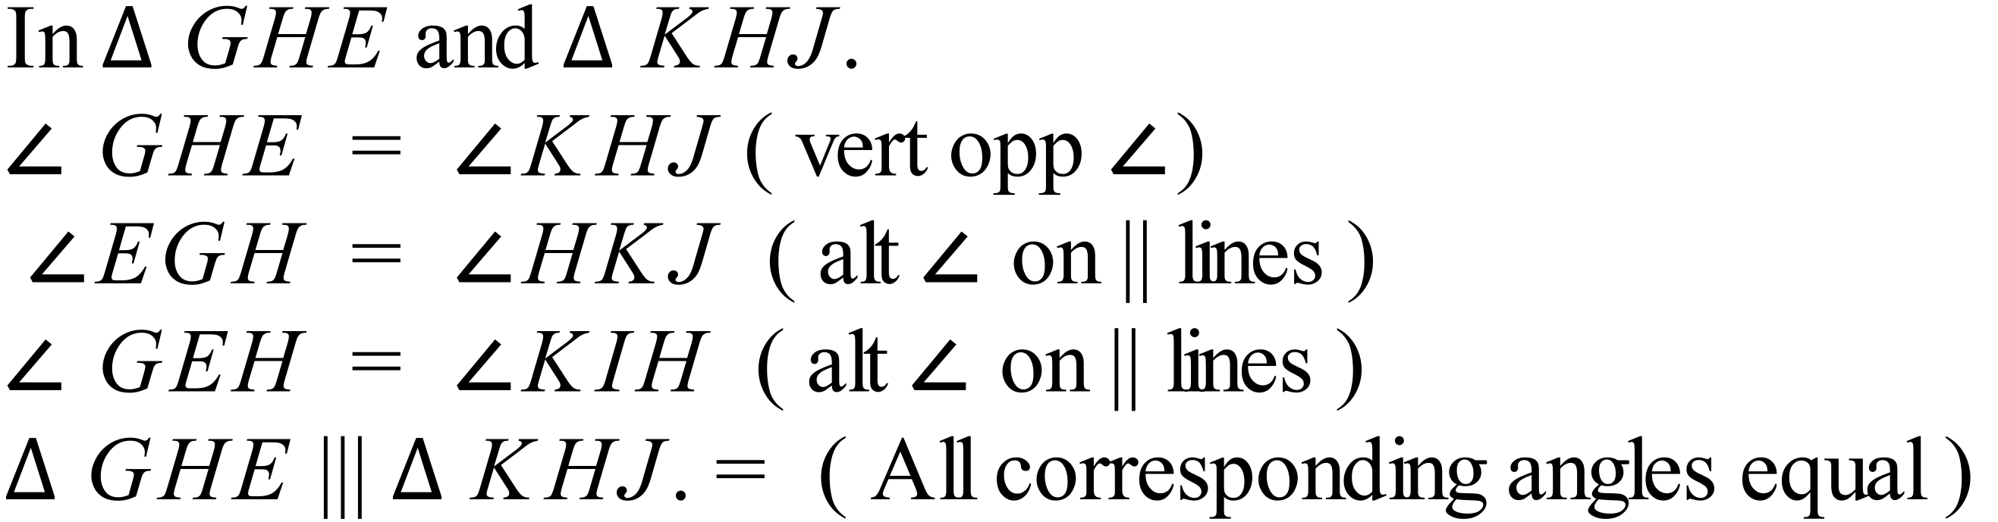  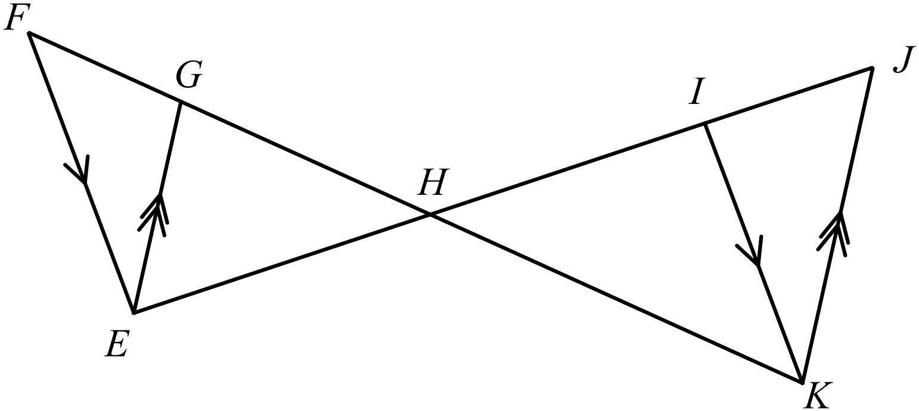 |  |  | A
 | 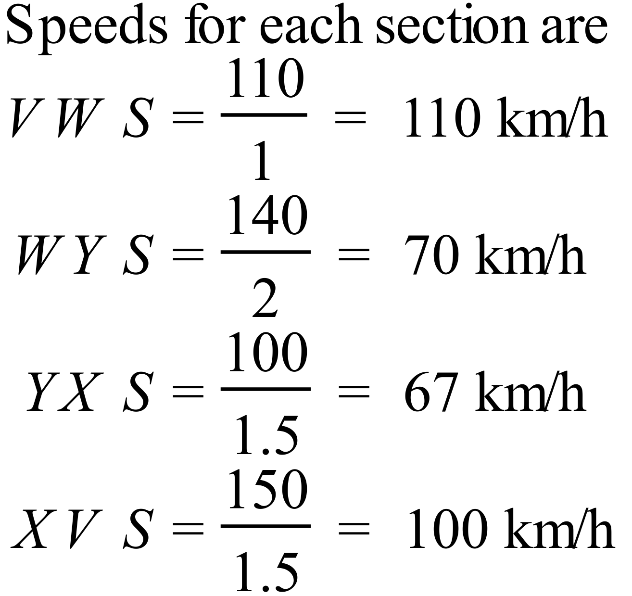  Slowest is 67 km/h |  |  | B
 | 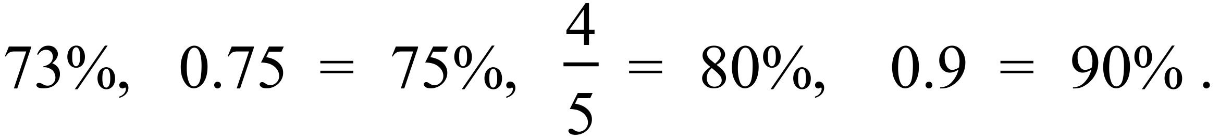 |  |  | C
 | 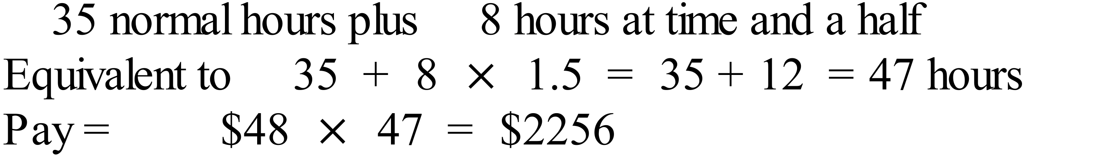 |  |  | B
 | 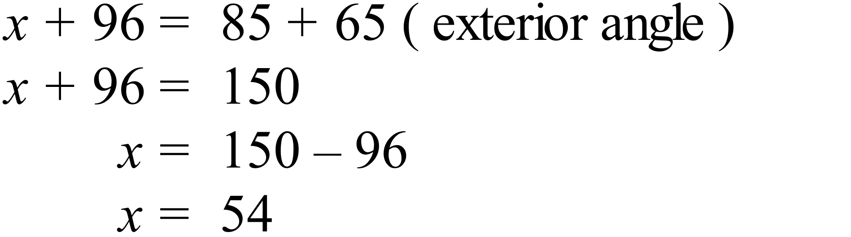 |  |  | B
 | 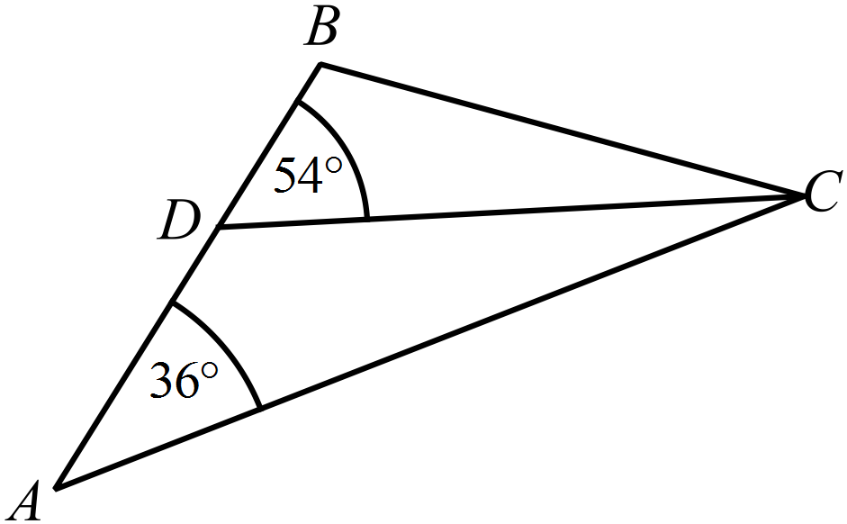  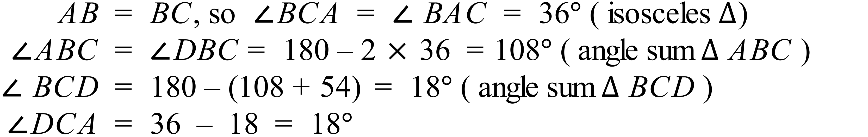 |  |  | A
 | 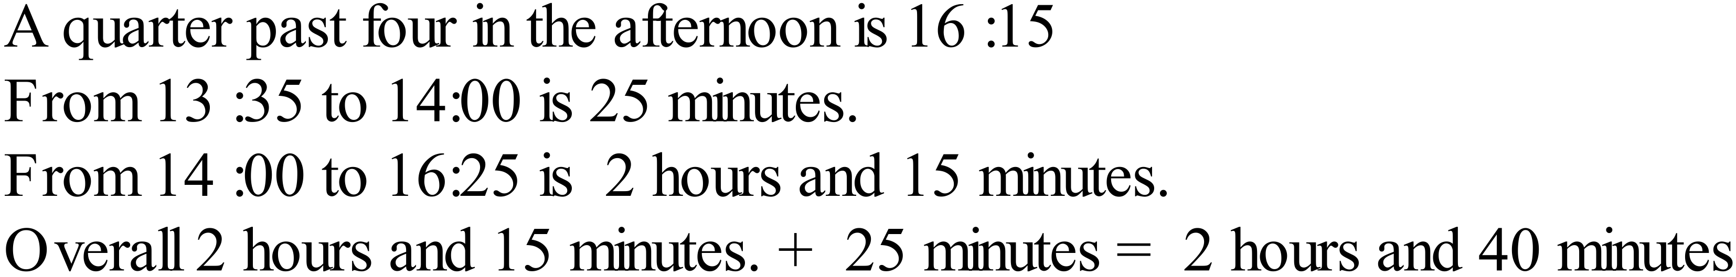 |  |  | D
 | 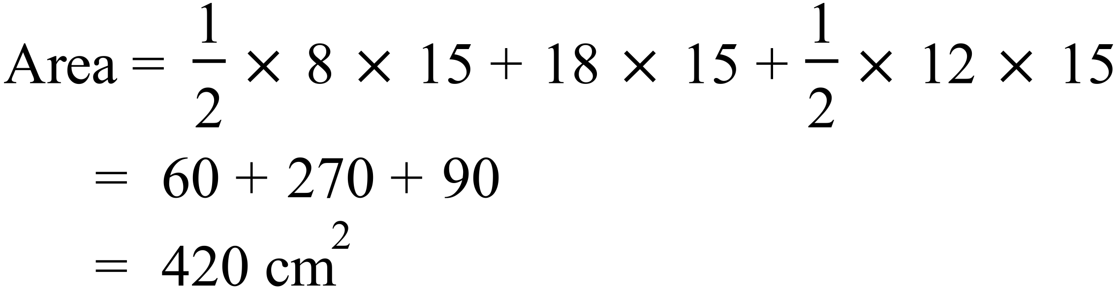 |  |  | C
 | 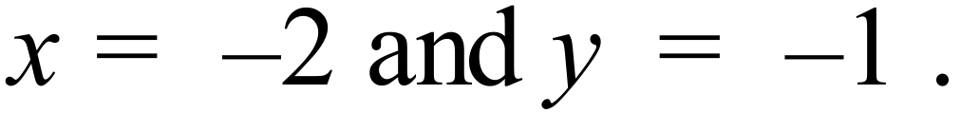  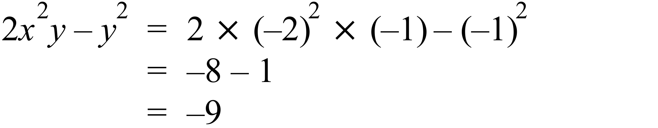 |  |  | A
 | 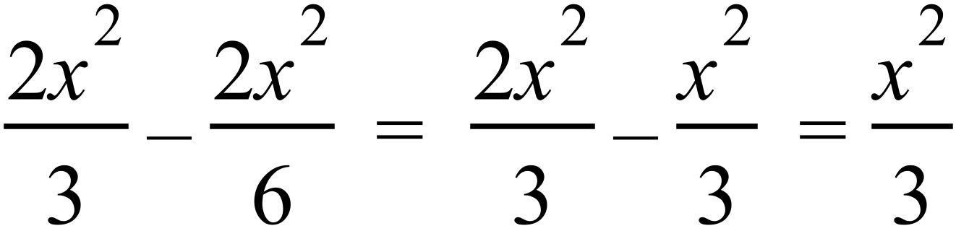 |  |  | B
 | 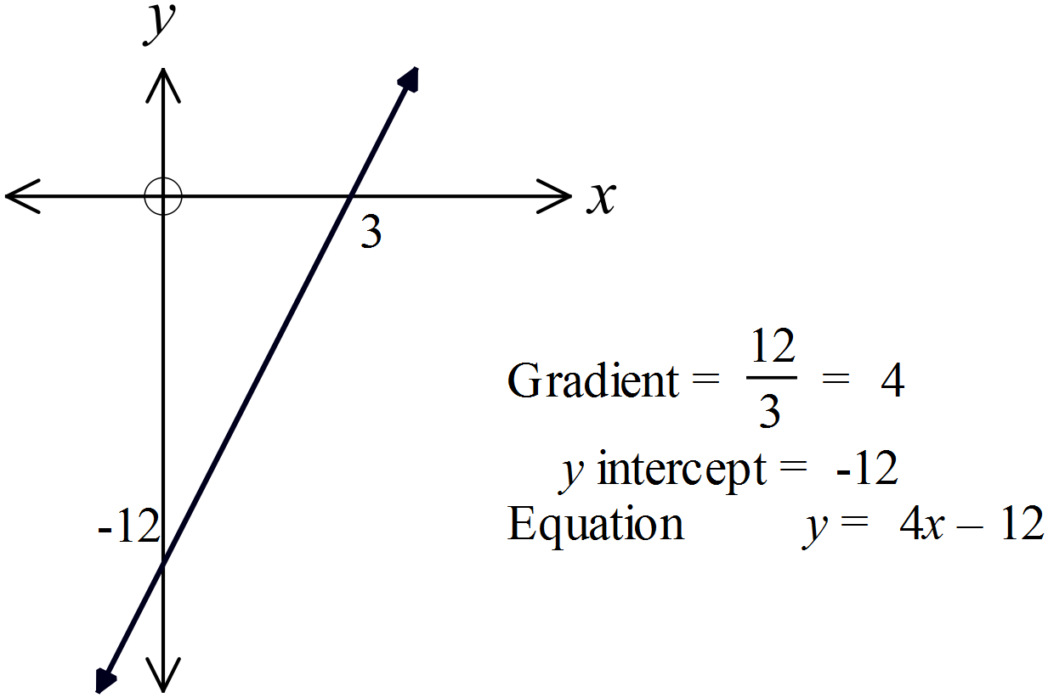 |  |  | D
 |  |  |  | C
 | 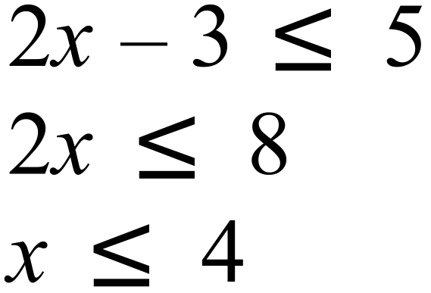  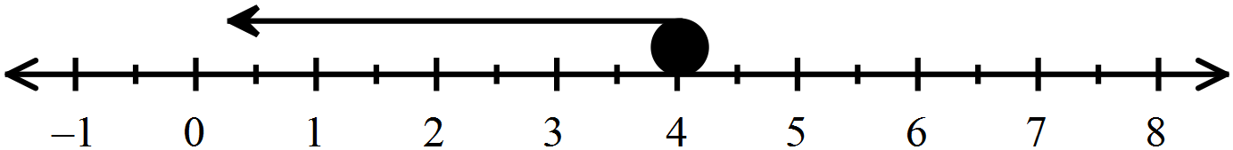 |  |  | C
 | The data is numerical and since there are points, it is discrete. |  |  | C
 | Q2 (median) = 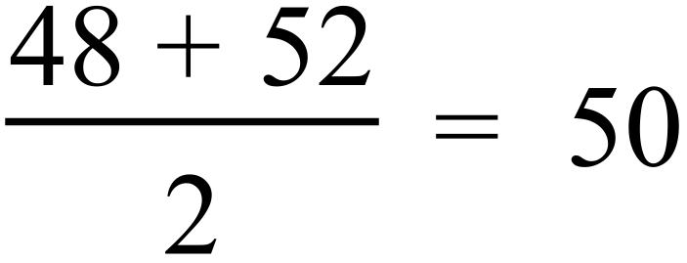  Q1 (1st quartile ) = 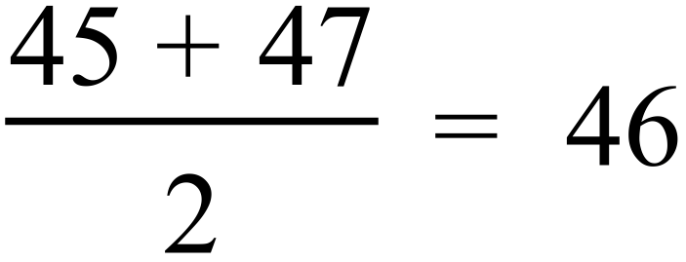  Q3 (3rd quartile) = 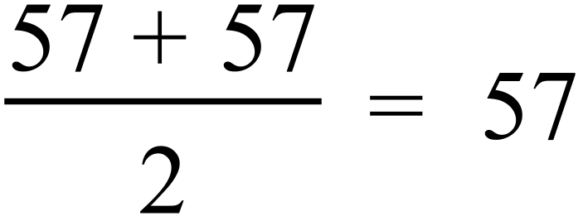  Interquartile range = 57 – 46 = 11 |  |  | B
  2 | 2 | 8 |  |  |  |  |  |  |  |  | Q1
  3 | 7 | 9
  4 | 5 | 7 | 8 | 8 | 8 | 8 |  |  |  |  | Q2
  5 | 2 | 4 | 5 | 5 | 7 | 7 | 8 | 8 | 9 |  | Q3
  6 | 0
 | P (56 or greater) = 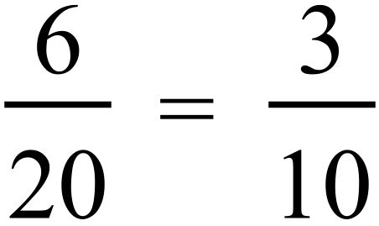  P (less than 56) = 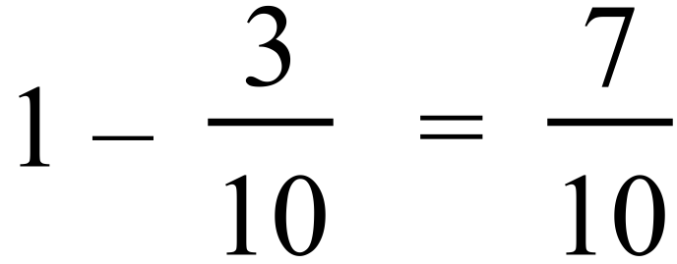 |  |  | D
 | 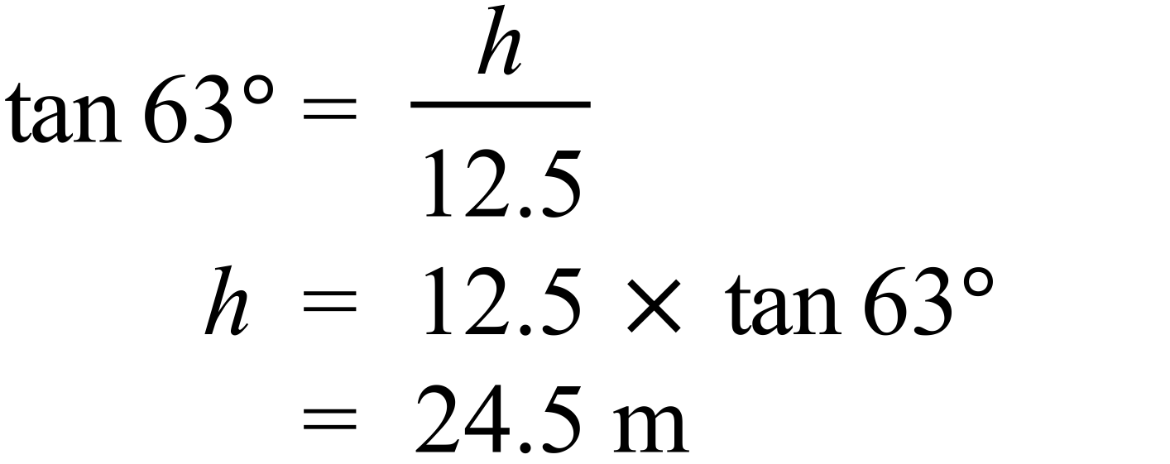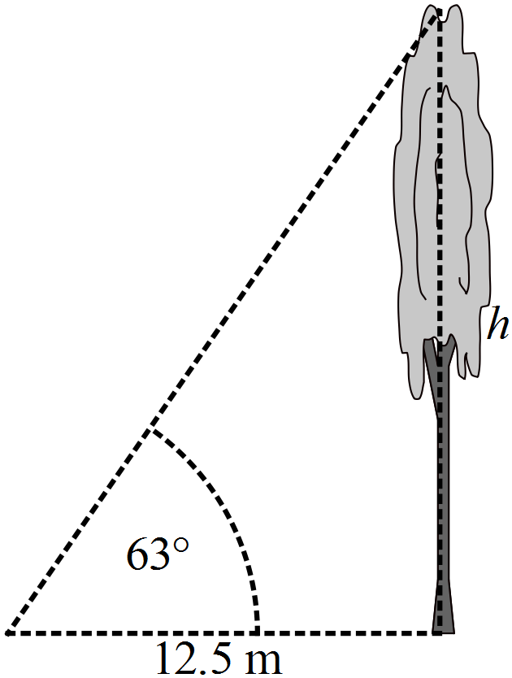 |  |  | D
 | 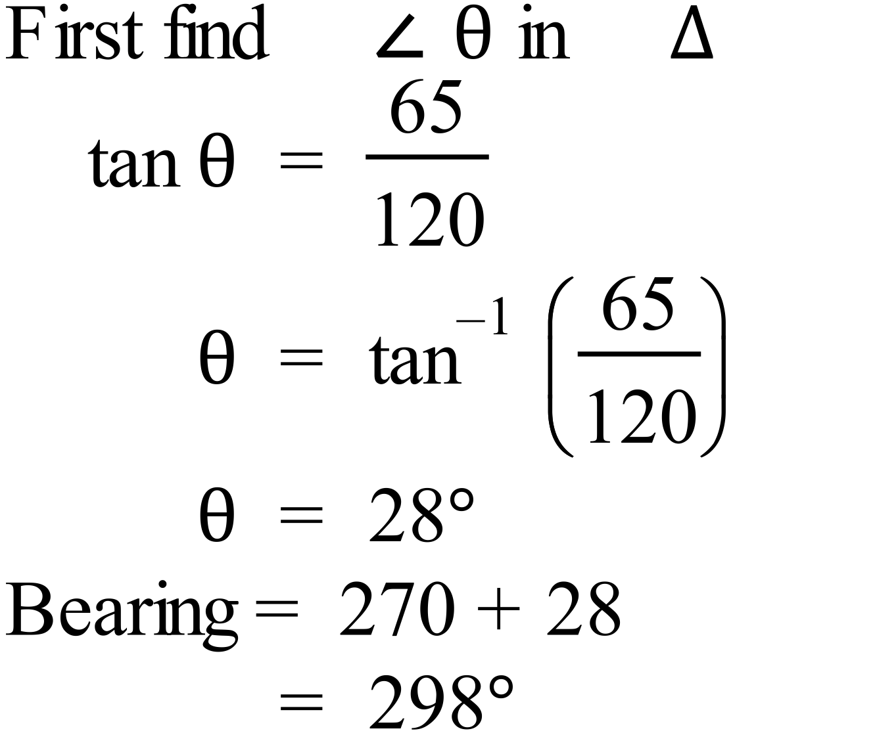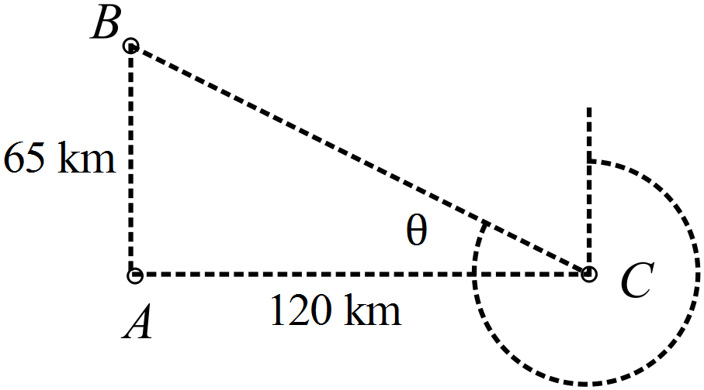 |  |  | D
 | 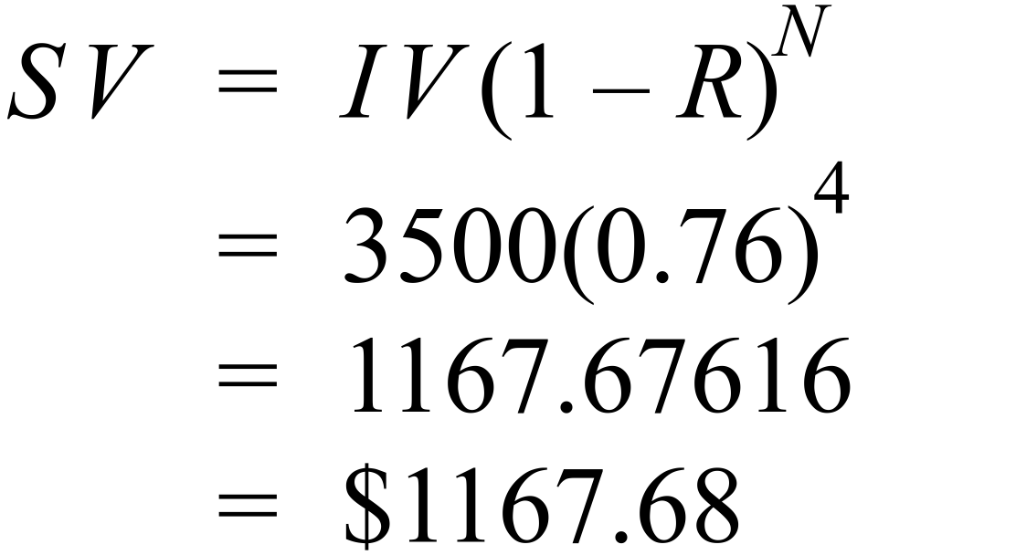 |  |  | A
 | 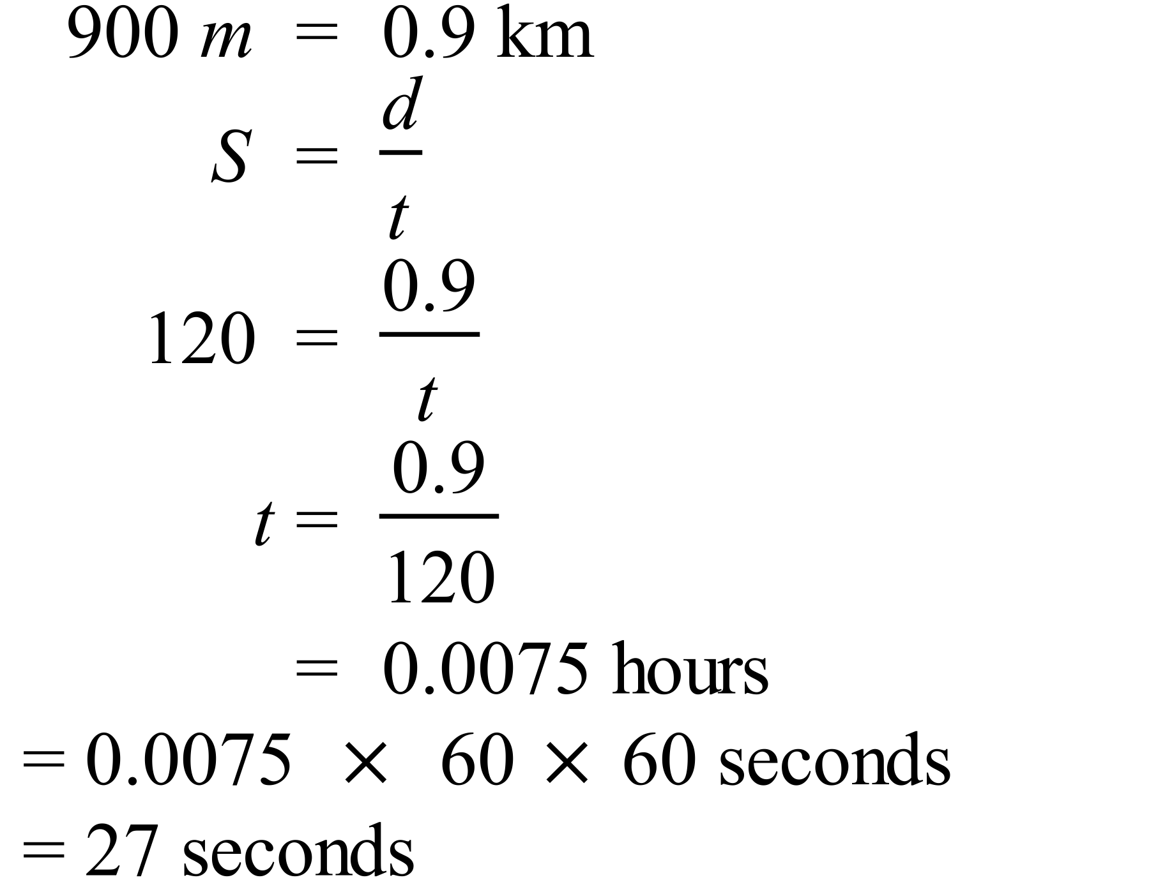 |  |  | A
 | 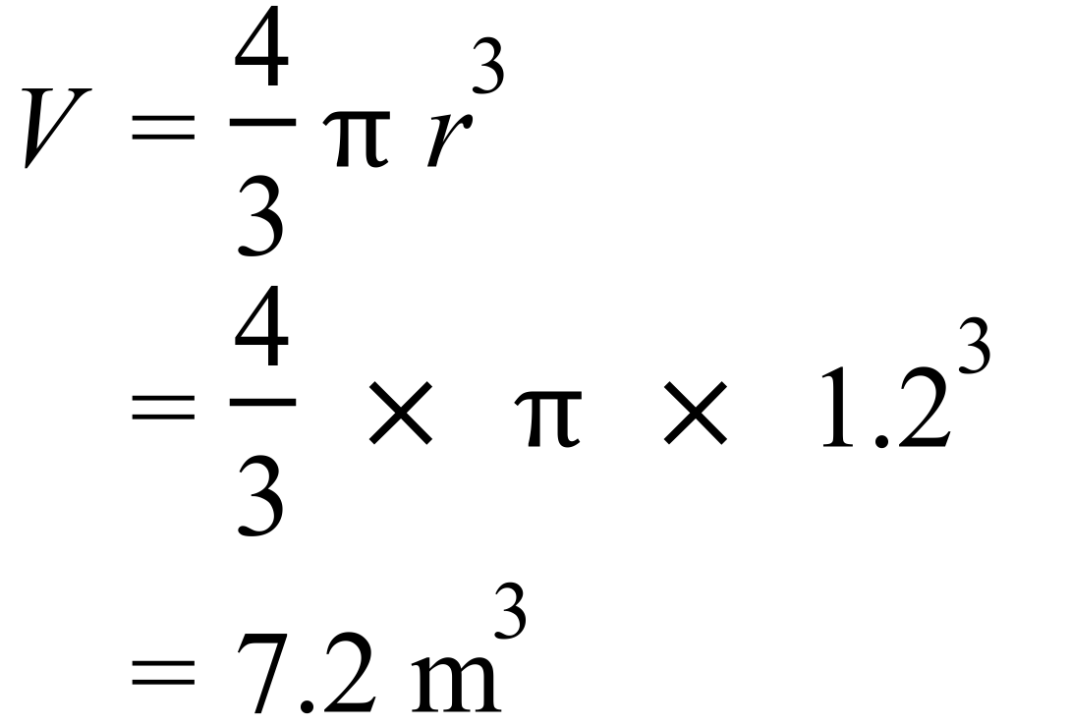 |  |  | A
 | 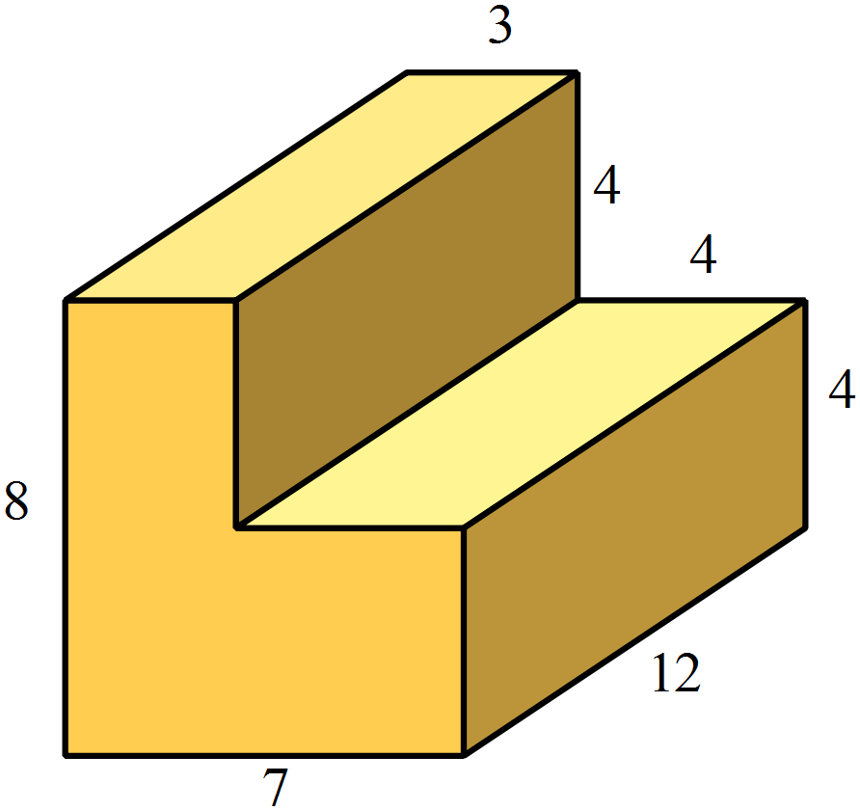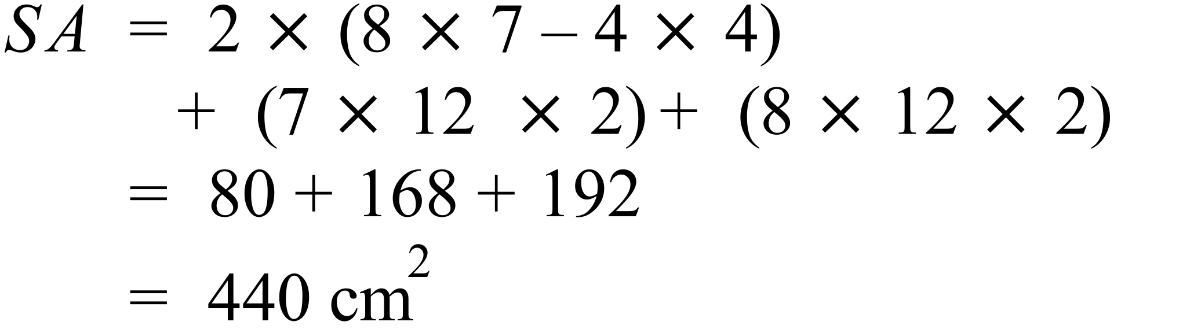 |  |  | B
 | 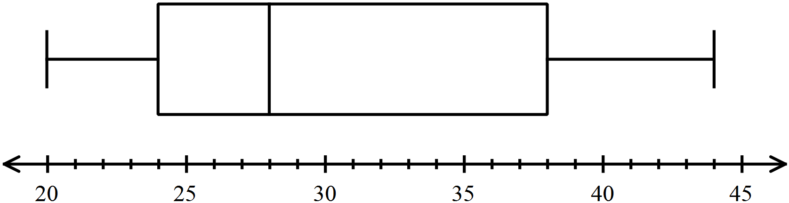  24 is the bottom of the box, so the lower quartile (25% mark).  44 is the top extreme (100% mark)  There are 75% of scores between these. |  |  | D
 | Both have a gradient of 2, so are parallel. |  |  | C
 | It is a concave down parabola, so the equation could be 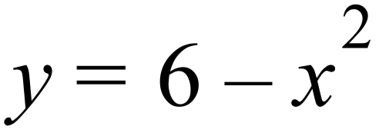 |  |  | C
 | The triangles are similar, one pair of equal angles given, and a pair of vertically opposite angles equal, so triangles are equiangular and hence similar.  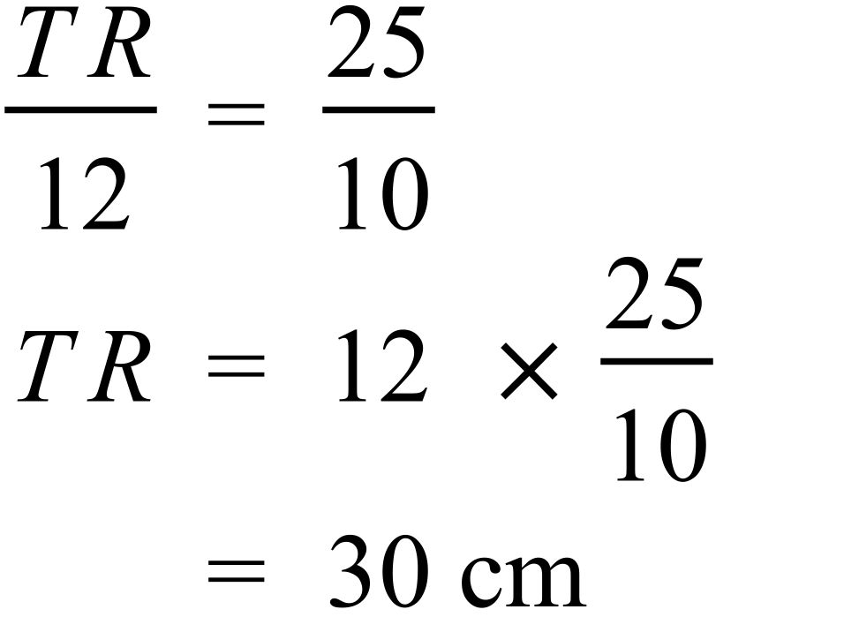 |  |  | B
 | A strong positive relationship indicates the points group around a straight line which has a positive gradient, so A meets this criteria. |  |  | A

School Name
Year 10 Yearly Examination
WME Yearly Maths Course 2015
Multiple Choice Section Answer Sheet
Name ________________________________ Teacher ________________________

Completely fill the response oval representing the most correct answer.
Use a black or blue pen or 2B pencil.

26. A B C D
27. A B C D
28. A B C D
29. A B C D
30. A B C D
31. A B C D
32. A B C D
33. A B C D
34. A B C D
35. A B C D
36. A B C D
37. A B C D
38. A B C D
39. A B C D
40. A B C D
41. A B C D
42. A B C D
43. A B C D
44. A B C D
45. A B C D
46. A B C D
47. A B C D
48. A B C D
49. A B C D
50. A B C D

51. A B C D
52. A B C D
53. A B C D
54. A B C D
55. A B C D
56. A B C D
57. A B C D
58. A B C D
59. A B C D
60. A B C D
61. A B C D
62. A B C D
63. A B C D
64. A B C D
65. A B C D
66. A B C D
67. A B C D
68. A B C D
69. A B C D
70. A B C D
71. A B C D
72. A B C D
73. A B C D
74. A B C D
75. A B C D

Year 10 |  | WME Yearly Maths | Calculator Allowed
Section 2 Part B Longer Answer Section
ANSWERS
 |  |  |  | Marks
76. | - The data is (positively) skewed. |  |  | 1 mark for correct answer
 | 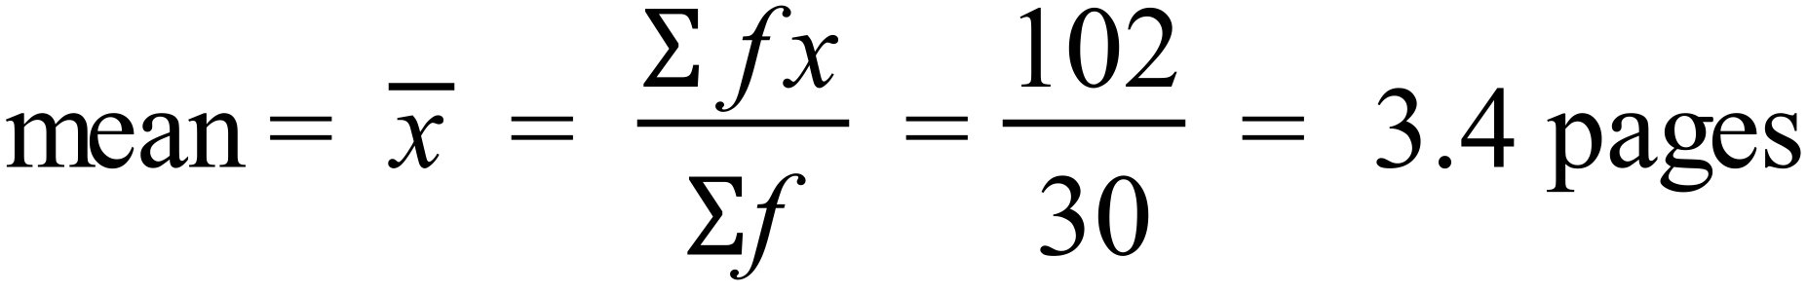 |  |  | 1 mark for correct answer
 | - Median = middle of 30 which are 15th and 16th scores.  From CF column Median = 3 |  |  | 1 mark for correct answer
 | - LQ = 8th score = 2  UQ = 23rd score = 4  Interquartile range = 4 – 2 = 2 |  |  | 1 mark for correct answer
77. | (a)  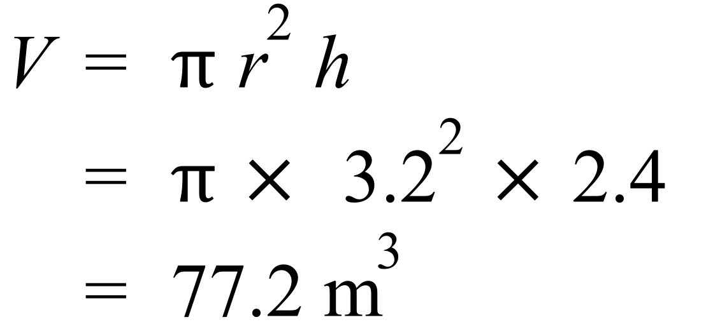 |  |  | 1 mark for correct answer
 | (b)  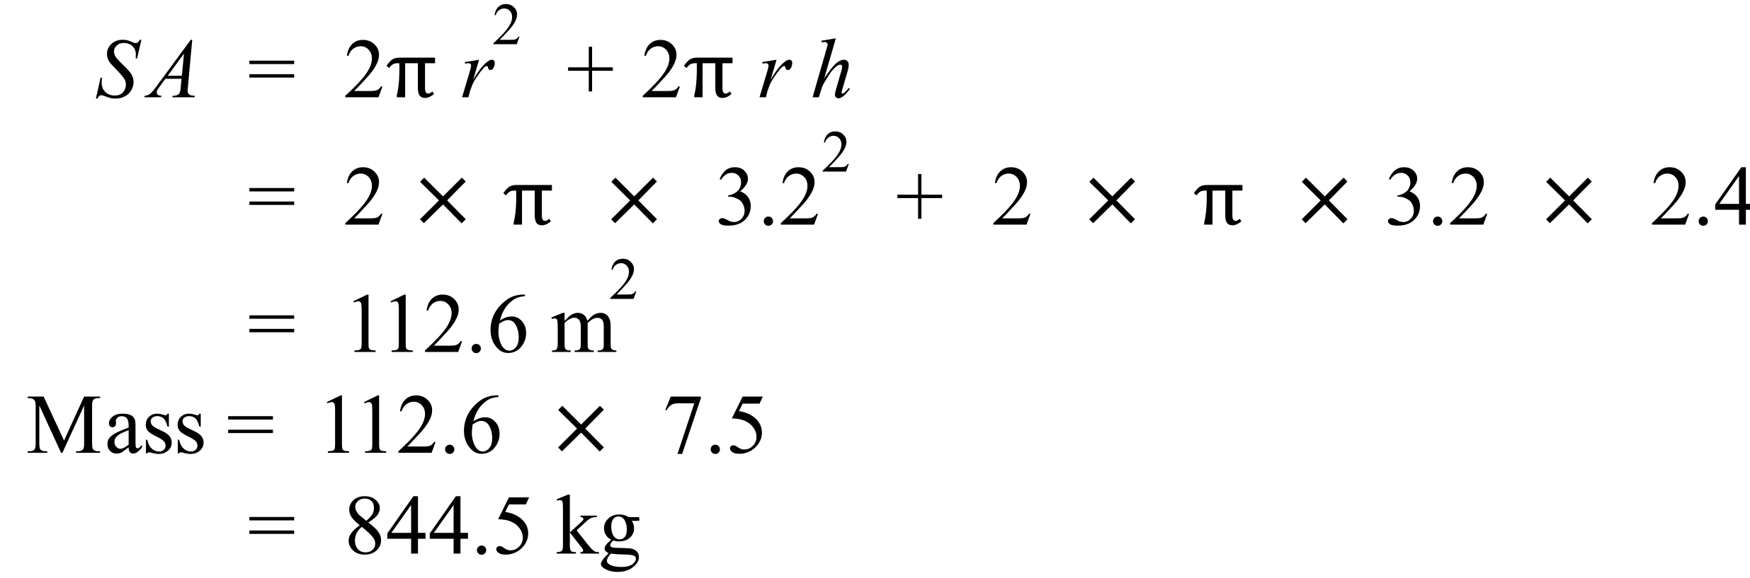 |  |  | 1 mark for correct SA  1 mark for correct mass calculated from SA found.
78. | (a)  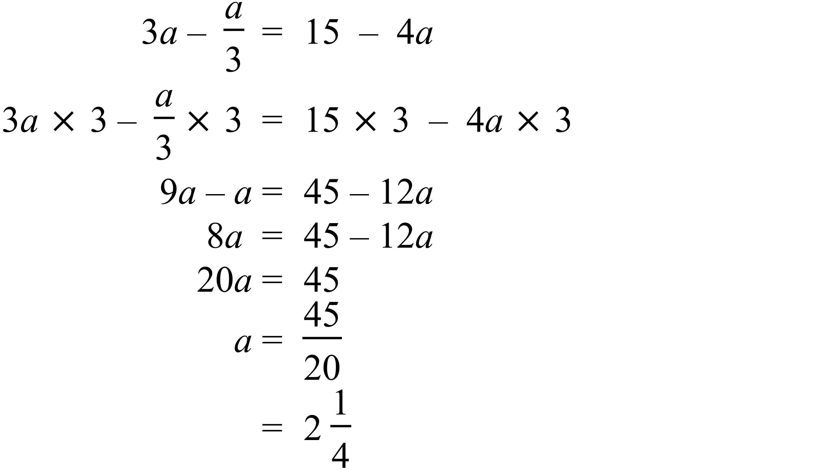 |  |  | 2 marks for correct answer with working.  1 mark for incorrect answer with minor error in working  1 mark for correct answer without working.
 | (b) 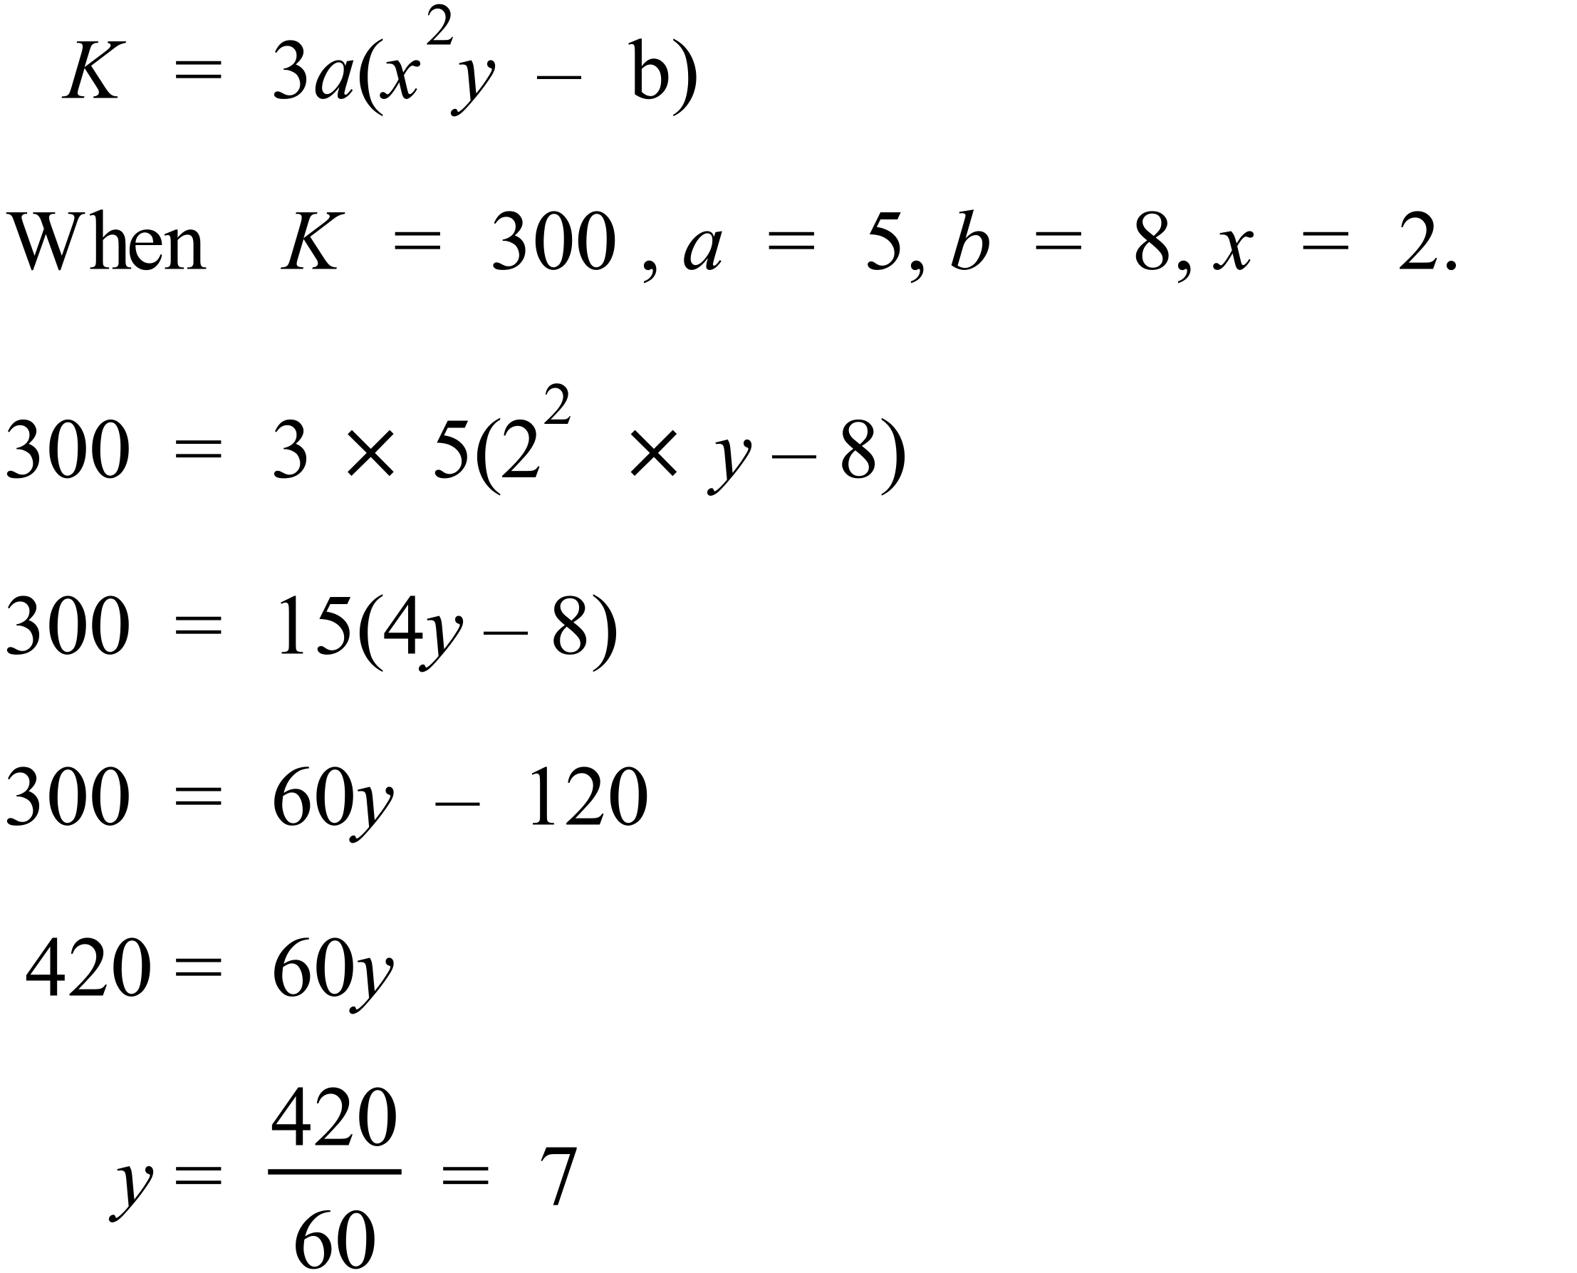 |  |  | 2 marks for correct answer with working.  1 mark for incorrect answer with minor error in working
79. | (a) 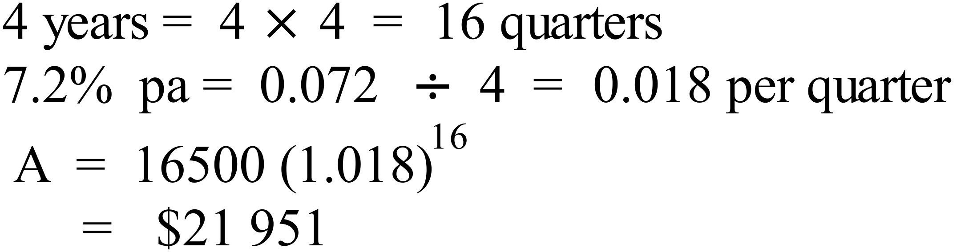 |  |  | 1 mark for correct answer
 | (b) 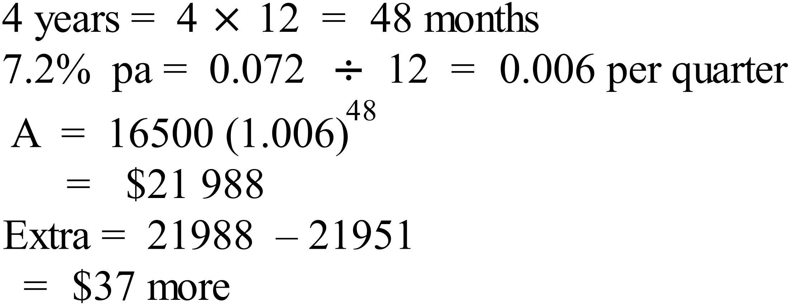 |  |  | 1 mark for correct answer
80. | The triangles AED and ABC are similar;  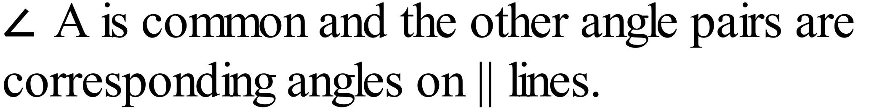  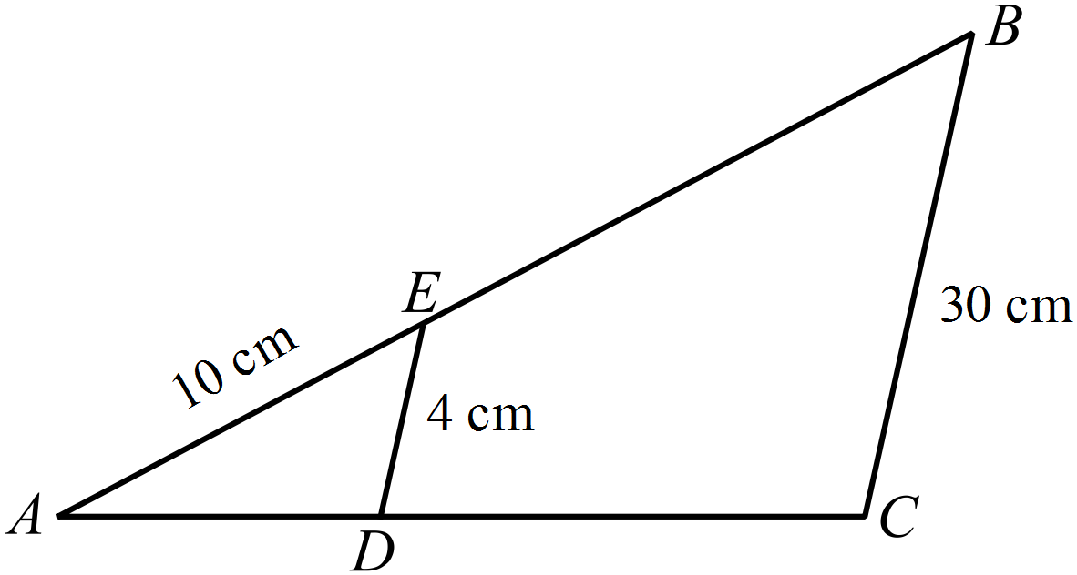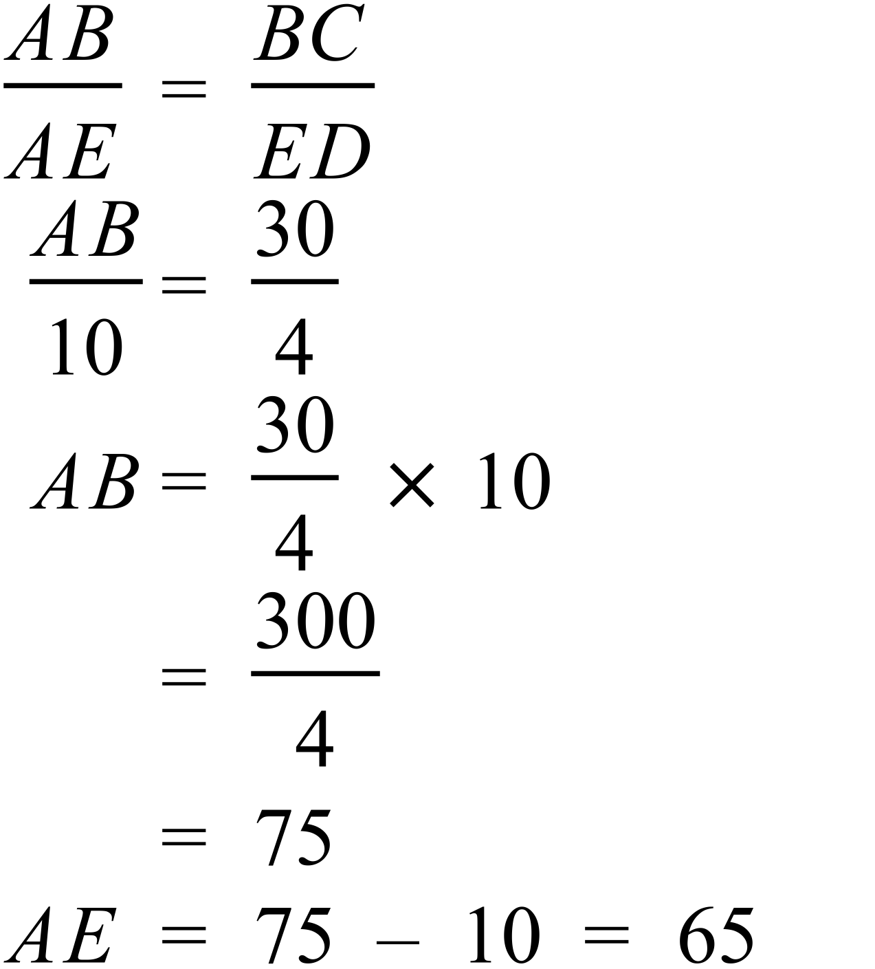 |  |  | 2 marks for correct answer.  1 mark for incorrect answer with minor error in working
81. | 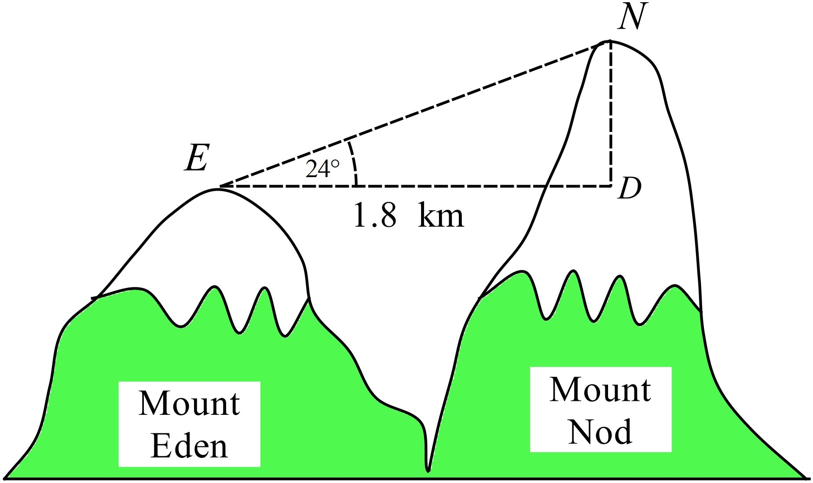(a)  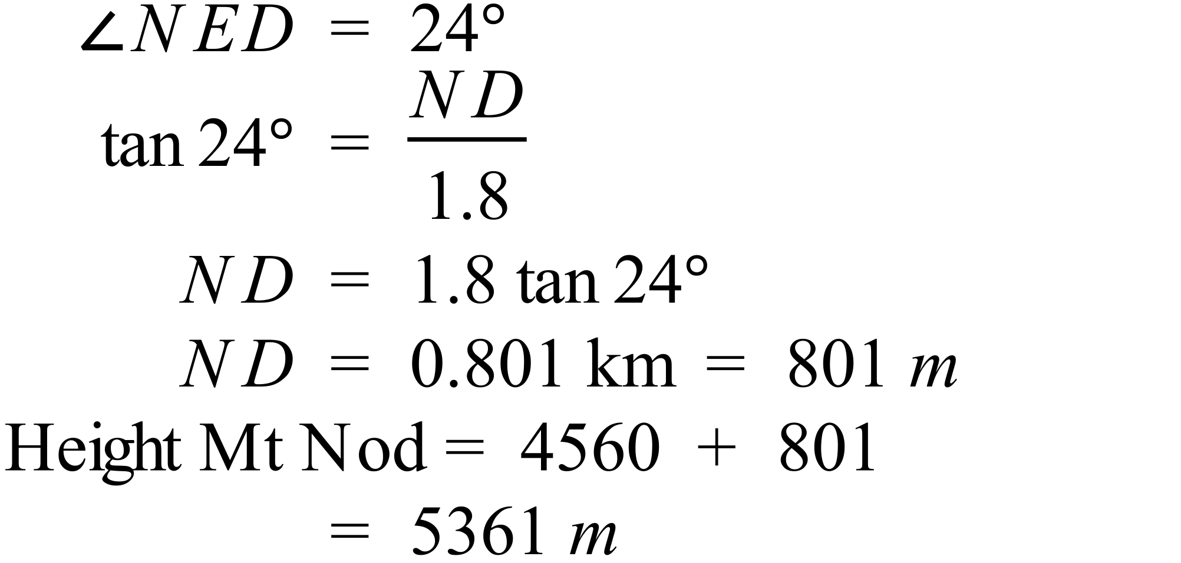 |  |  | 2 marks for correct answer.  1 mark for incorrect answer with minor error in working  Or if ND found correctly but not the height of Mt.
 | 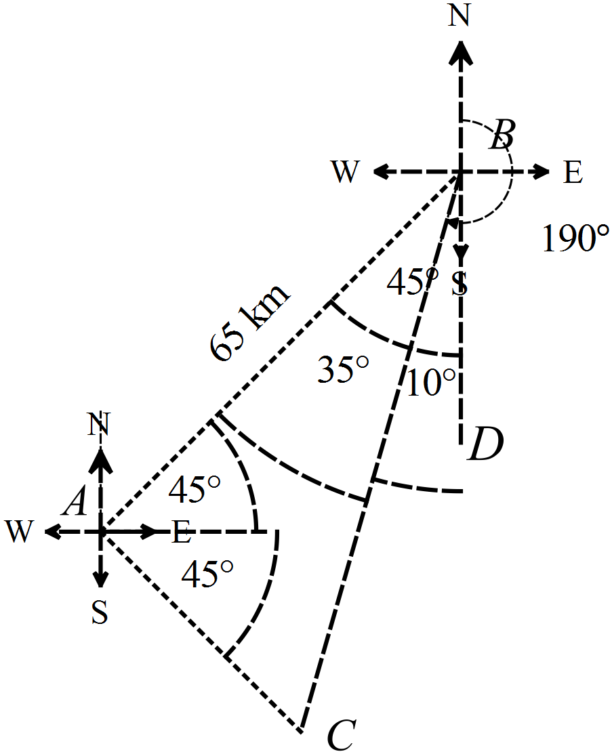 (b)  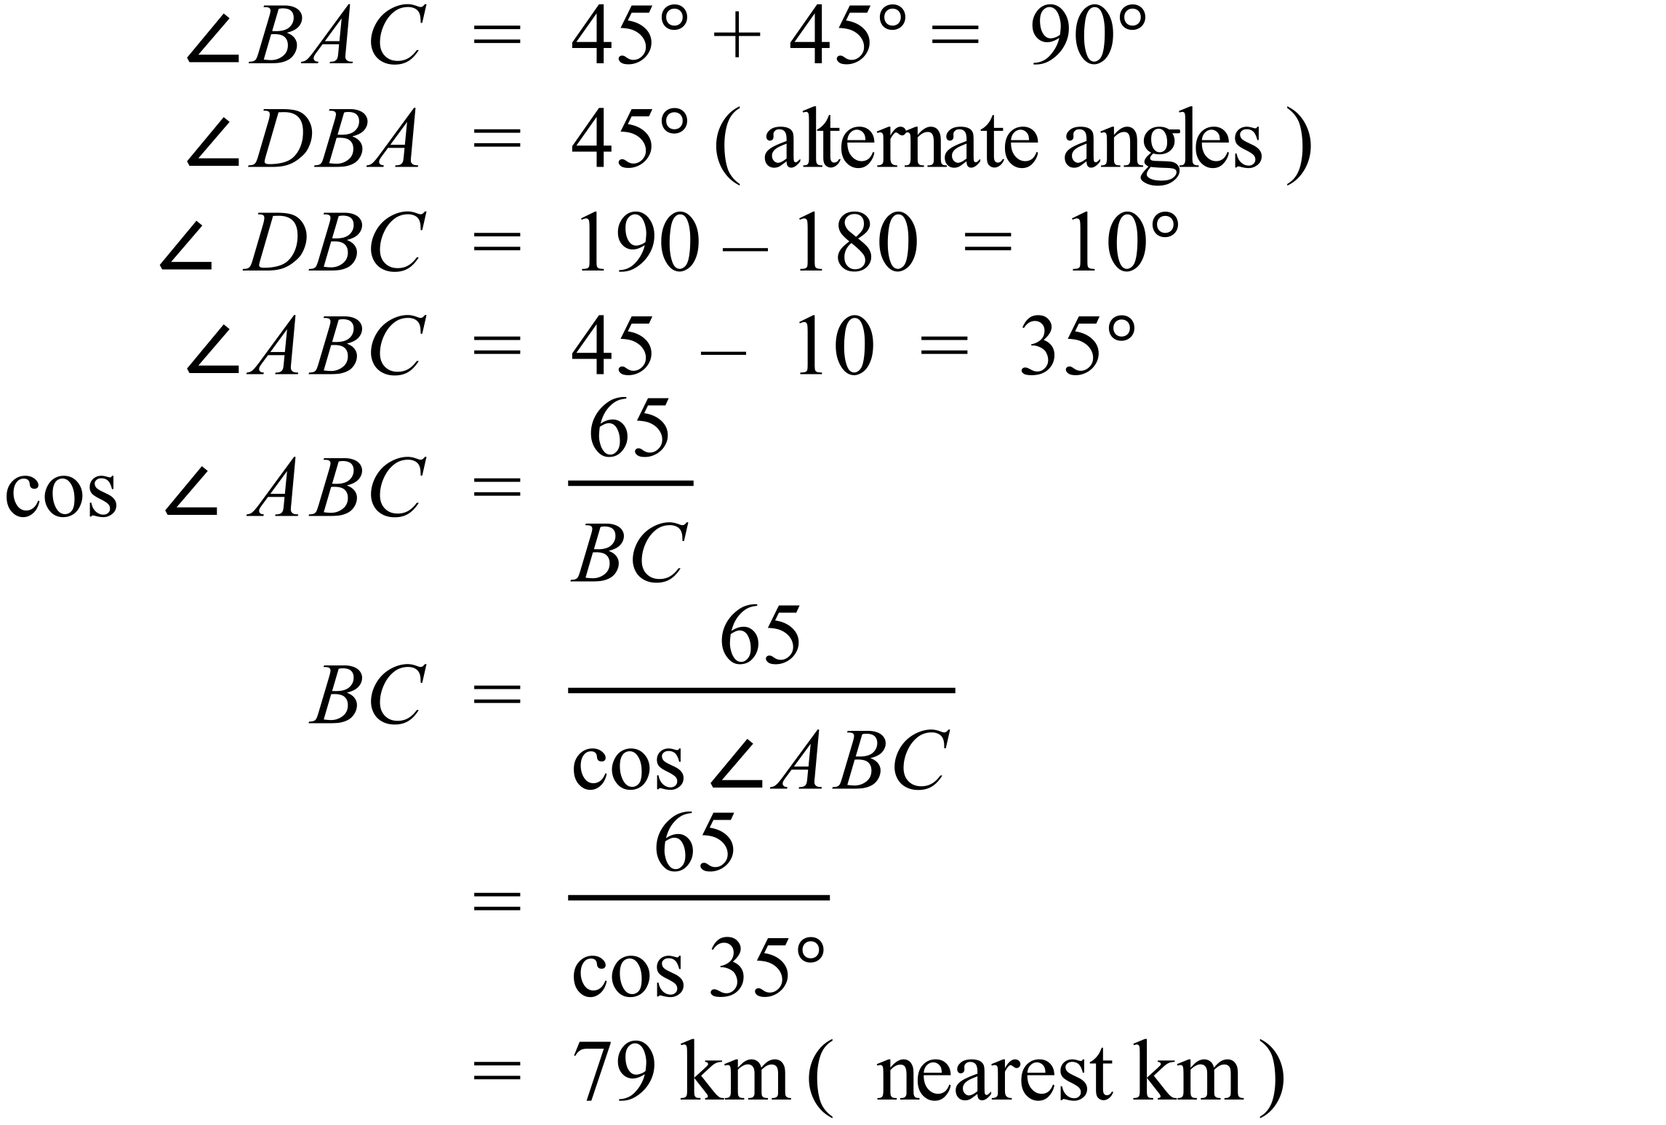 |  |  | 2 marks for correct distance.  1 mark for an answer with working which has minor errors in reasoning or calculation.

82. | 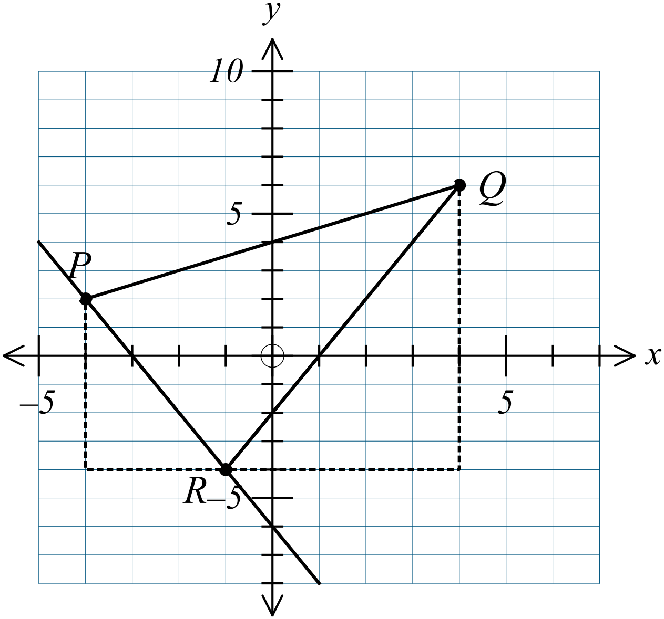
 | (a)  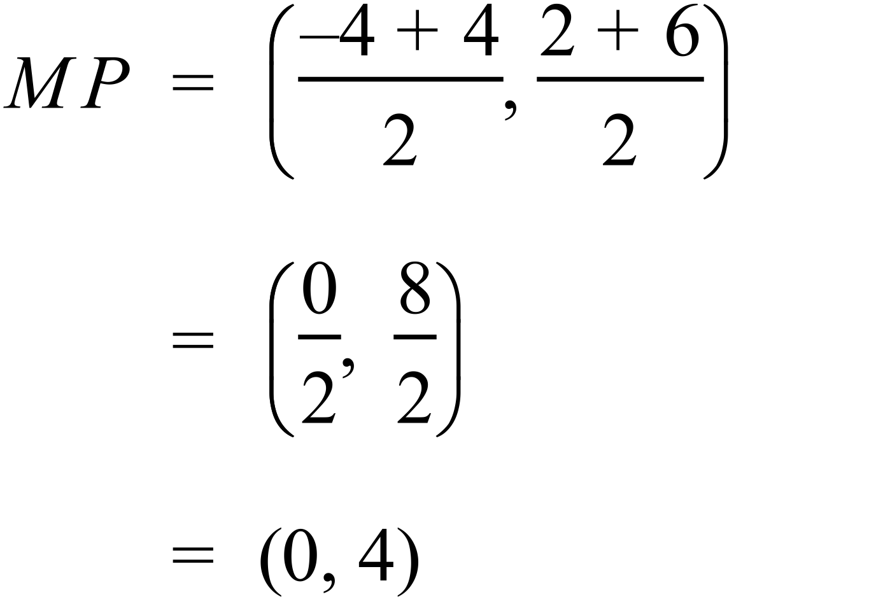 | 1 mark for correct answer
 | (b)  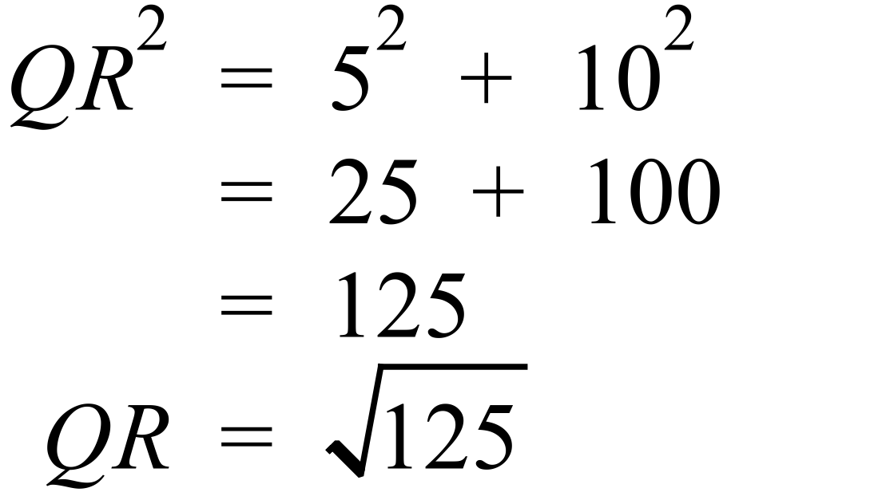 | 1 mark for correct answer
 | (c)  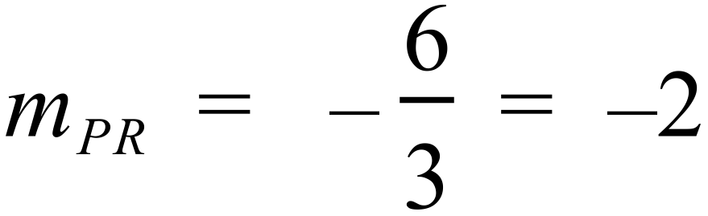 | 1 mark for correct answer
 | (d)  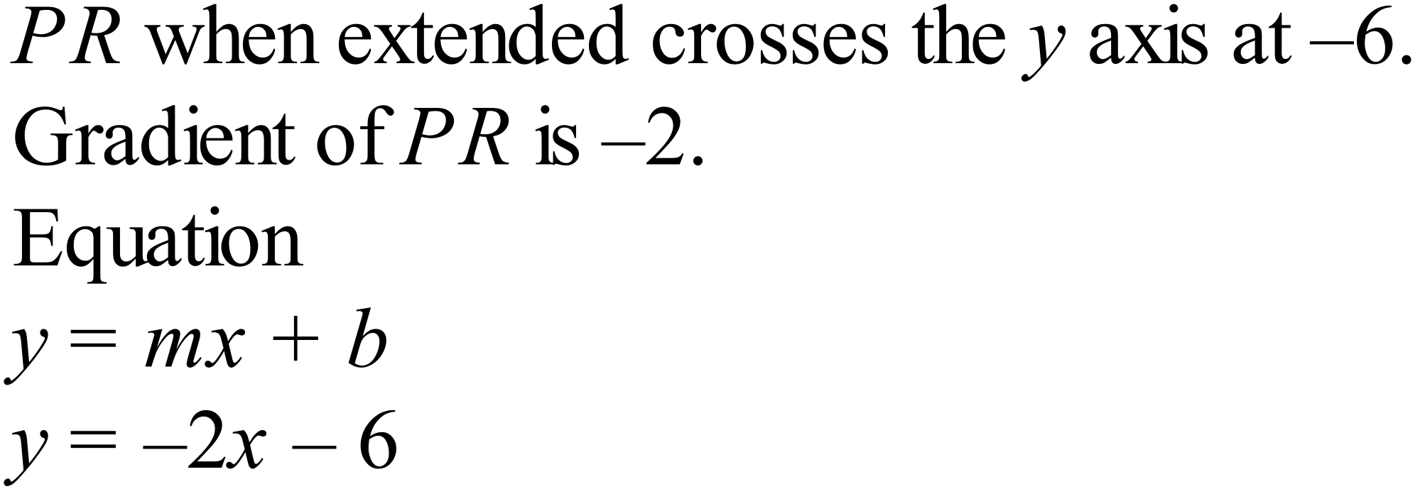 | 1 mark for correct answer
83. | 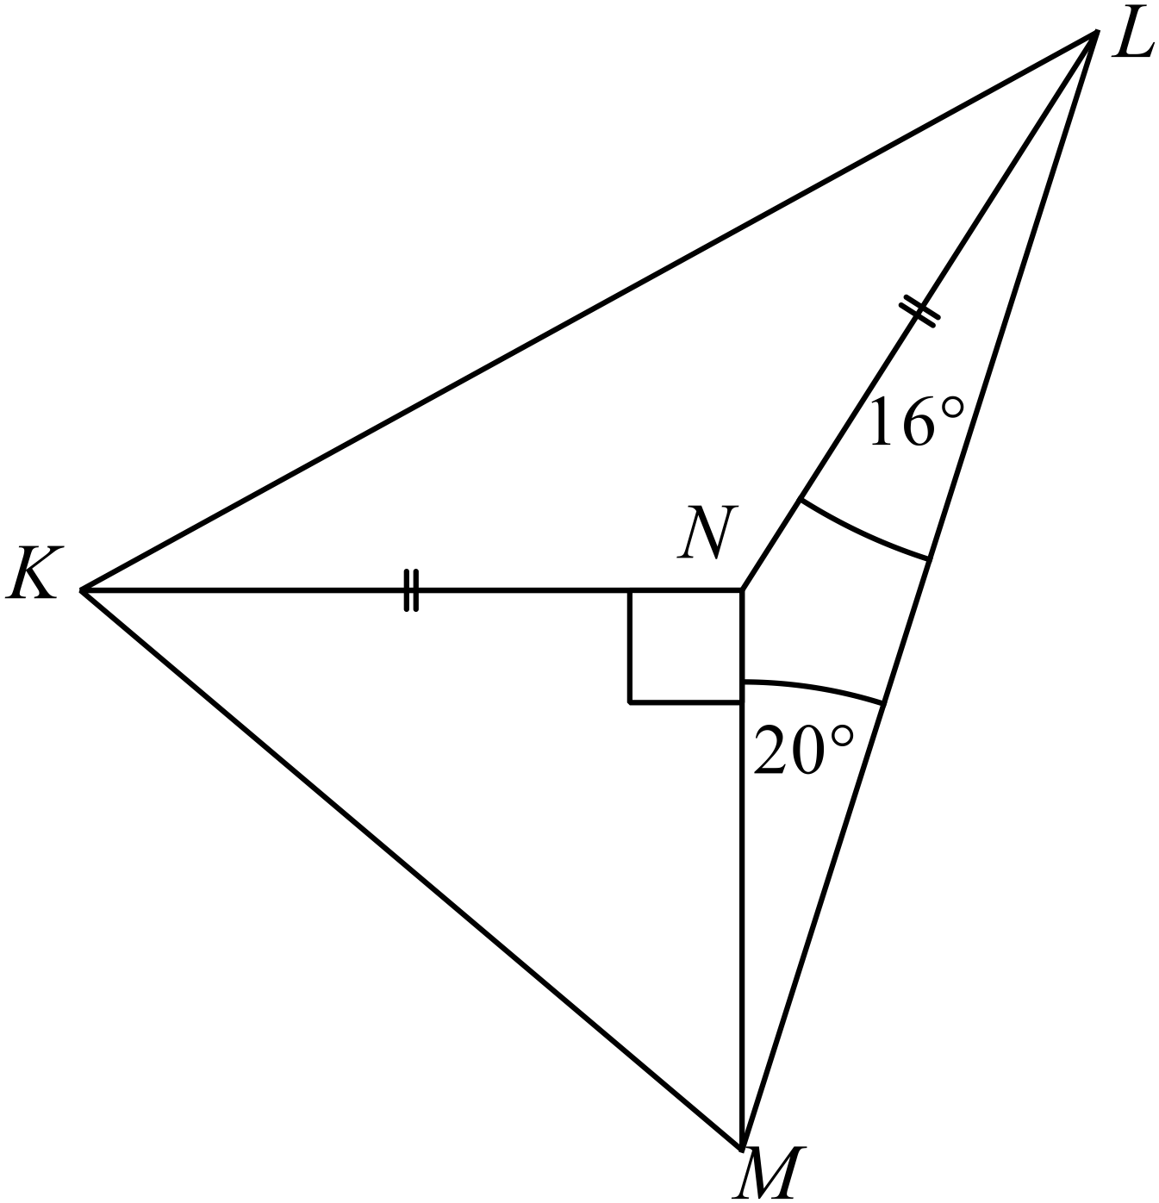
 | (a) | 1 mark for correct answer
 | (b)  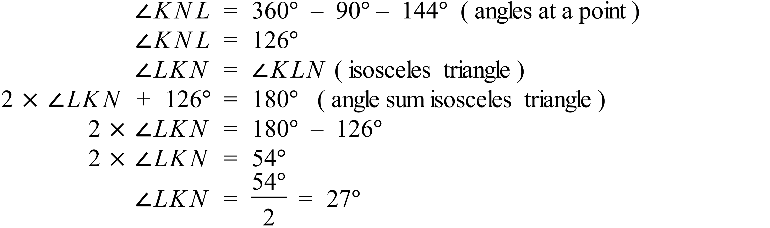 | 1 mark for correct answer

